**VAG ECU MAP Guide**

Table of Contents

1. Diesel engine control 2

A Brief guide to ECU control of a diesel engine 2

2. WinOLS Guide 7

Beginners guide to using WinOLS 7

Starting with WinOLS 7

Finding MAP in WinOLS Manually 13

Single Value Boost Limit (SVBL) 17

To help with MAP identification 20

3. Understanding ECU MAPS. Part 1 25

4. Understanding ECU MAPS. Part 2 37

5. WinOLS. Making MAP changes. EGR example 44

# Diesel engine control

## A Brief guide to ECU control of a diesel engine

To control a modern diesel engine you need to control:

* Fuel injected quantity (IQ)
* Fuel injection timing (SOI)
* Fuel injection duration

In order to control fuel injection you must know how much air is flowing into the engine and you must know the engine speed.

So you have 5 factors very closely linked.

1. Mass of Air Flowing (MAF)

2. Fuel Injected quantity

3. Fuel injection timing

4. Fuel injection duration

5. Engine speed (rpm)

The following guide  based on a 1.9 tdi pd VAG engine.

This engine has a capacity of 1.9 litres or 1900 cubic centimetres (cm3).

The exact figure is actually 1897 cm3.

The engine has FOUR cylinders so each cylinder is 474 cm3. (1897/ 4)

All four cylinders are identical so we only need to deal with one.

If one cylinder has a volume of 474 cm3, the maximum amount of air & fuel it can hold is 474 cm3.

### Fuel request (Drivers wish)

The electronic accelerator pedal sends a signal to the ECU showing how much the driver is pushing the pedal down. The measurement is usually a percentage. 0 % is no push so the engine idles. 100 % is full or Wide Open Throttle.

So at 0 % throttle the injectors must give a fixed QUANTITY of fuel, for a fixed DURATION starting at a fixed TIME. This results in a pre-set idle speed. e.g. 900 rpm.

So the idle speed has been Mapped to a specific value for MAF, QUANTITY, DURATION and TIMING.

At 100 % throttle the injectors must give a fixed quantity of fuel, for a fixed duration starting at a fixed time. So 100 % throttle has been Mapped to a specific value for MAF, QUANTITY, DURATION and TIMING.

This means that every other percentage from 1 % to 99 % will also need to be Mapped to a specific value for MAF, QUANTITY, DURATION and TIMING.

### How much fuel should be Injected?

The ECU knows how much fuel to inject because it knows how much air is in the cylinder. So we need to know about AIR before we decide about FUEL.

If our cylinder has a volume of 474 cm3, the maximum amount of air & fuel it can hold is 474 cm3.

If we ignore fuel for a moment, it means the maximum amount of air that the cylinder can hold is 474 cm3

If air was a liquid, life would be easy. The amount of a liquid that fits into 474 cm3 is 474 cm3.

Air is a gas and so you can fit different amounts of air into the same space.

### So how much air fits into 475 cm3 ?

This is determined by the density of the air and the density of the air depends on the surrounding temperature and pressure.

The density of air at sea level and on a warm day is between 1mg/cm3 and 1.2 mg/cm3.

Let’s assumes air density is 1.0 mg/cm3.

So our 474 cm3 cylinder will hold 474 x 1.0 mg of air, which is 474 mg of air.

So every stroke of one piston will suck in 474 mg of air. This is referred to as 474 mg/stroke.

So now we know how much air is in our cylinder (474 mg. We can inject some fuel.

### Injecting fuel (IQ)

Our cylinder holds 474 mg of air.

Diesel burns at maximum efficiency at roughly 14.6 mg of air to 1 mg of fuel. So 474 mg of air can efficiently burn 32.5 mg of diesel fuel. (474 / 14.6)

So we inject 32.5 mg of fuel and off we go. Not really.

This doesn’t mean the injectors inject 32.5 mg of fuel per stroke (mg/stroke).

32.5 mg/stroke is the ideal maximum, assuming a normal air supply (EGR shut)

If the injectors inject more than 32.5 mg/stroke, some of the fuel won’t burn properly and will come out of the engine as black smoke. (This is often described as the smoke limit).

The injectors can inject any amount of fuel less than 32.5 mg/stroke and that’s what they do.

At idle the injectors may be injecting as little as 6.0 mg/stroke.

To make the engine speed rise the INJECTION QUANTITY is increased

The injection quantity is controlled by a map in the ECU often called Drivers Wish.

At idle the accelerator pedal will be set at 0 %, so no EXTRA injection will occur because idle speed is controlled by an idle speed map, not the Drivers Wish map.

When fully pressed down (wide open throttle. WOT) the accelerator pedal will be 100 %.

So the ecu receives a signal varying between 0 % and 100%.

If you apply 30 % accelerator pedal the ecu consults the built in DRIVERS WISH MAP checks the required INJECTION QUANTITY and injects that amount.

SIMPLE.

Unfortunately this is not simple because diesel engines don’t really measure how much fuel they inject.

Fuel injection is very complicated these days, so this is a very simple explanation.

Imagine a fuel injector is like a doctor’s syringe loaded with 100 mg of fuel.

The driver presses the accelerator pedal and WISHES for 30 %. The ecu consults the DRIVERS WISH MAP and decides to inject 16 mg of fuel. SIMPLE.

BUT

When do you inject the fuel and how long will the injection take?

Engine designers measure time in degrees of rotation of the CRANKSHAFT. That is why you hear people referring to engine timing.

The ideal point to inject the fuel is generally taken as Top Dead Center.(TDC). This is the point when both valves are usually shut and the air has been squashed to its maximum.

TDC is often referred to as Degrees Before Top Dead Center (BTDC) or Degrees After Top Dead Center. They are both the same thing, just opposites of each other.

So 4°BTDC is the same as -4° ATDC. (Only BTDC is used here).

Injecting 16 mg of fuel will take time (DURATION) and because the piston is going up and down, you need a START OF INJECTION point.

Lets assume 2 mg of fuel takes 1 degree of crankshaft rotation (°CR) to inject.

Assuming that the injection best time is 0°BTDC and 16mg will take 8°CR to inject. (DURATION)

Injection will need to start at 8°BTDC instead of at 0°BTDC.

Start of Injection (SOI) has to be 8 degrees BTDC so that all the fuel has been injected by 0°BTDC.

So the ecu needs maps to decide on:

* INJECTION QUANTITY as requested by the accelerator position.
* INJECTION DURATION as calculated from the injection quantity
* INJECTION START (SOI) as calculated from the injection quantity.

Assuming that the engine is in perfect condition, the maps for Injection Quantity, Injection Duration and Start of Injection will be accurate.

So a precise amount of fuel will be injected for the correct amount of time (DURATION), starting exactly on time. (Start Of Injection)

The ecu can be sure of this because the crankshaft and camshaft sensors give precise details of the piston positions. These measurements end up on the dashboard as engine speed measured in Revolutions Per Minute (rpm).

Below is a graph showing the amount of fuel (IQ) being injected into a cylinder to cause the engine rpm to rise.

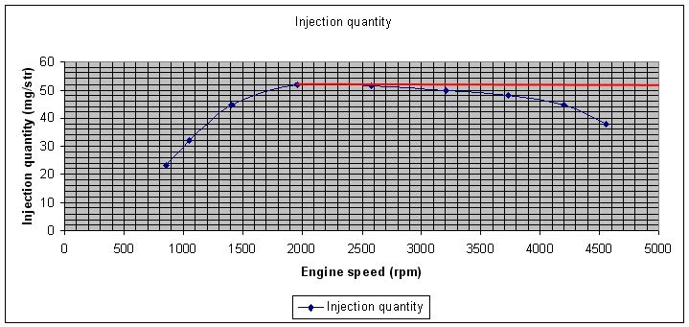

On this graph you can see that:

* At idle (850 rpm) the ECU is injecting 23mg of fuel.
* 32mg IQ raises engine speed to 1050 rpm.
* 45mg IQ raises engine speed to 1400 rpm.
* 52mg IQ raised engine speed to 1900 rpm.
* The ECU could carry on injecting 52mg to make engine speed rise higher (As per the added RED line)
* BUT it doesn’t.
* 52mg IQ raises engine speed to 2550 rpm but after that IQ is reduced by the ECU.
* 50mg IQ is used to achieve engine speed 3200 rpm.
* 48mg IQ is used to achieve engine speed 3750 rpm.
* 44mg IQ is used to achieve engine speed 4200 rpm.
* 38mg IQ is used to achieve engine speed 4550 rpm

So the ECU is LIMITING IQ as the engine speed rises.  Why is IQ being limited? The amount of fuel being injected (IQ) must be limited for a number of reasons.

1. We can only inject fuel if we have enough air to allow it to burn. This is the Air supply limit known as MAF limit or smoke limit. (See smoke map)

2. We only want to produce engine power in a smooth controlled manner to protect the clutch, gearbox etc. This is the Torque limit. (See Torque map)

Lets look at limiting factors.

### ****AIR SUPPLY CONTROL****

We have established that our 474 cm3 cylinder will hold 474 x 1.0 mg of air, which is 474 mg of air.

So every stroke of one piston will suck in 474 mg of air.

The ECU can measure the Mass of Air Flowing thanks to a Mass Air Flow (MAF) sensor.

This sensor constantly monitors the air flow and sends a signal to the ECU. Typically the air flow varies from 0 to 1000 mg/stroke.  The MAF needs to read above the normal atmospheric value of 474mg because of the addition of a turbocharger.

The MAF sensor plays a big role in EGR function but I won’t go into that here.

So our smoke map or IQ limit by MAF is based on information coming from the MAF sensor on the engine. Obviously the MAF sensor must be in good condition and give accurate results or the ECU will make the wrong IQ calculations.

### ****CONTROLLING AIR PRESSURE – TURBOCHARGERS.****

Air pressure and temperature vary depending on where you live in the world, weather etc.

The following assumes an air temperature around 20 °C and an air pressure of 1000 millibar (mbar).

Let’s assume our engine cylinder is receiving air at 1000 mbar pressure and 20 °C temperature at a rate of 474 mg/stroke. (To keep things simple, I am assuming no EGR is involved)

A typical turbocharger boost value adds an extra 1000 to 1500 mbar of air pressure. So a typical turbo boost pressure graph against rpm will run from 1000 mbar (no boost) up to 2500 mbar max boost. (That’s an extra 1500 mbar boost)

The extra air pressure means extra air so if we have 474 mg of air at 1000 mbar we can have 948 mg of air at 2000 mbar. (2 x 474) So with twice as much pressure we have twice as much air in the cylinder and can burn twice as much fuel at the same efficiency as before.

This results in the engine developing more power.

The engine ECU needs to know the boosted air pressure so the engine has a boost pressure sensor (manifold absolute pressure (MAP) sensor.).

The ECU also needs to know the air temperature so the engine has an Intake Air Temperature (IAT) sensor.

The desired Boost for engine speed and IQ is controlled by the Boost map. This map tells the ECU how much boost is required for a specified engine speed and IQ.

So we stamp on accelerator, get maximum IQ, maximum boost and off we go.  Not really.

The turbocharger doesn’t instantly change its turbine speed and boost pressure. It needs to spin up to speed. So the ECU needs to allow for the ‘spin up’ time.

Once up to speed the turbocharger will give maximum boost as per the boost map, which is fine for acceleration but most drivers don’t accelerate all the time, they cruise. So at 70 mph on the motorway the engine may have 2500 rpm thanks to high gearing.

IQ may have dropped to 32mg/stroke so the air needed is less than during acceleration so we don’t need lots of boost.

So the ECU needs to be able to control boost levels and make decisions about them.

### Turbocharger boost control.

As explained earlier the turbocharger needs to be controlled because the engine design and fuelling maps assume a certain BOOST level under certain engine speed and IQ conditions.

The engine ECU therefore uses the boost pressure sensor (MAP sensor.) and Intake Air Temperature (IAT) sensor to gather data about current boost conditions.

These sensors allow the ECU to compare current boost pressure with boost pressure maps stored in the ECU.

(The ECU also has a Single Value Boost Limiter (SVBL) which acts like an emergency cut off for boost.)

The turbo boost map controls the boost level inline with the required IQ.

The actual control of boost is via an electrical signal that controls the opening of a vacuum valve called the N75 valve.

The engine ECU varies this electrical signal to vary the amount of opening of this valve.

The ECU contains a map for N75 Duty cycle. The map ensures that the correct amount of boost is available as set by the Boost map.

Boost control has a limiting map known as the boost limit map.  This map is to protect the turbocharger. It is based on the measurement of atmospheric air pressure.

Remember we decided to think of air pressure as 1000 mbar at 20 °C.

If the atmospheric air pressure and temperature never change we won’t need a boost limit map.

In real life, air temperature changes all the time and atmospheric pressure changes with the weather and when we drive up and down mountains so our cars will need a boost limit map to protect the turbocharger and stop the ECU raising IQ when the turbocharger can’t provide enough air. (Like when you drive up a mountain…If you do

If the boost stays outside the range of the boost limiter for too long, the ECU will switch the boost OFF. (Limp mode)

The engine ECU also contains a Single Value Boost Limiter just in case the turbo control fails. The turbo will be switched off if the actual boost goes above the Single Value Boost Limiter. (SVBL).

Hopefully the above information will give you a clue about your turbocharged diesel engine and how it works.

Lots of things in the ECU are inter-linked and changing one ECU map can have unexpected effects on other maps so it is vital that you think before you act.

The most basic changes in the ECU mapping will require changes to

1. Drivers wish map

2. IQ limit by MAF (smoke map)

3. Boost map

*Attention! Do not play with ECU maps until you understand what they do. Mistakes can be expensive!*

# WinOLS Guide

## Beginners guide to using WinOLS

The information and examples are from VAG PD 1.9 tdi engines.

You need a chip tuning interface and program tool to extract the engine ecu file from your own engine ECU. If you just want to learn about mapping, you don’t need to do that.

Join a chip tuning website forum and have a look for a download section. Download an original map for your car. You may not find the exact one, but something close will probably be available. You can use this map as your learning data source.

The map will come as a zipped file which will need unzipping and storing somewhere obvious like “my documents”.

Next you need a program to examine the file (hexdump). One of the best is available FREE in DEMO version from EVC at [www.evc.de/en/download/down_**winols**.asp](http://www.evc.de/en/download/down_winols.asp)

## Starting with WinOLS

Click on Project to open the drop down menu shown below.

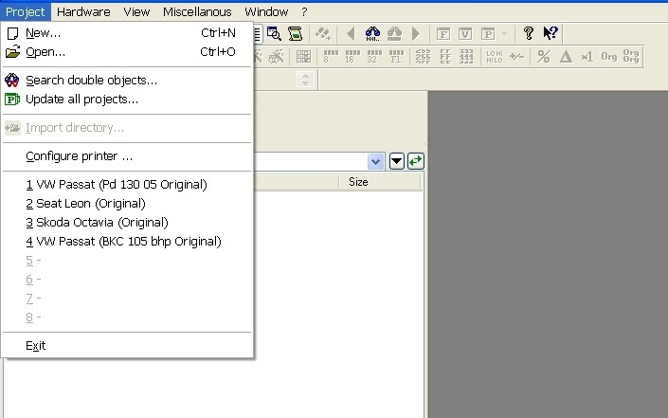

A new window and a pop up will appear. Click Ok to create your new project.

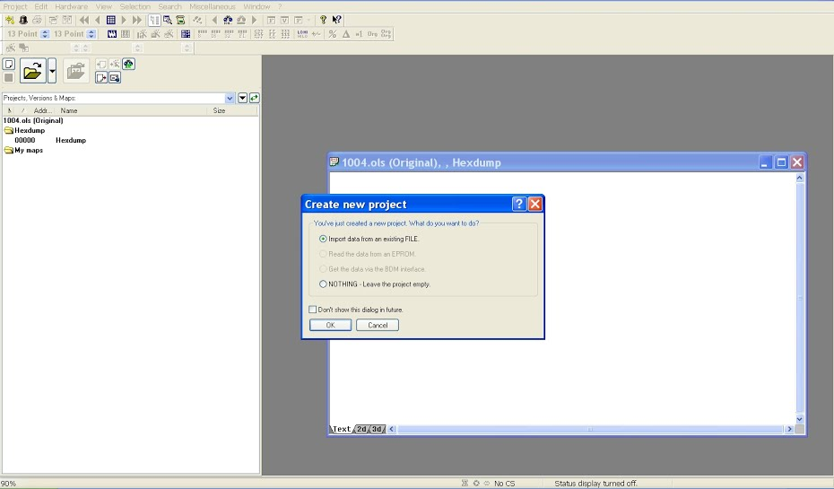

A new pop up will ask what format your project will be in. You need to choose the format that suits your stored file. If you have a single file, you probably want the first one (Binary). If your file looks like two files, you want the second one. (Two binary files eg HiLow.)

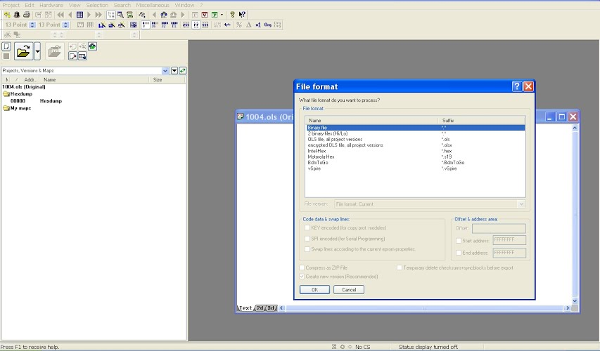

The next screen will be the standard windows screen for opening any file on a computer. Navigate to where-ever you have your saved file and click open.

A new screen will appear asking you to give details of the file.

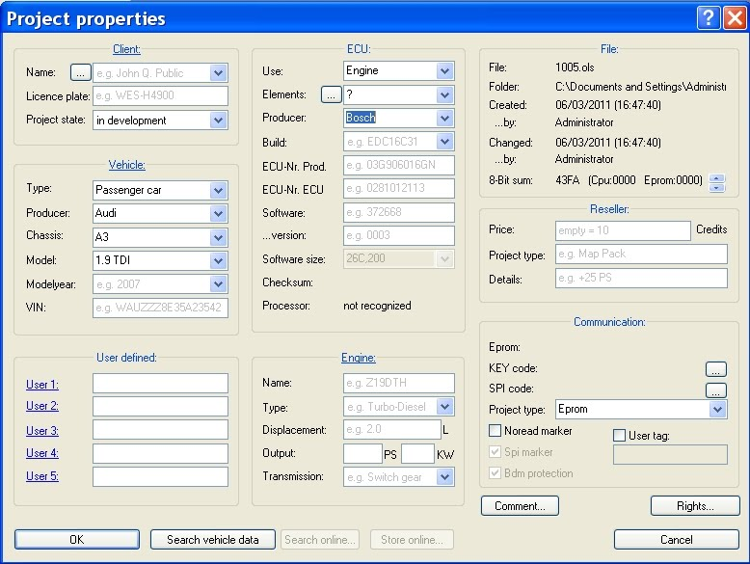

Winols will have automatically entered any data it has gained from the file. Check that it has identified the ECU producer. E.g Bosch and also the ECU build, if possible.

Click “OK”.

After a few seconds your file name will appear in the left hand window. This will be followed by “Hexdump” , “My maps” and “Potential maps”. If you click on Potential maps, a list of Auto discovered maps will appear. The actual hexdump will appear in the large right hand window.

Any auto discovered maps will have an outline drawn round them along with a name and two numbers. Eg. 8 x 10.

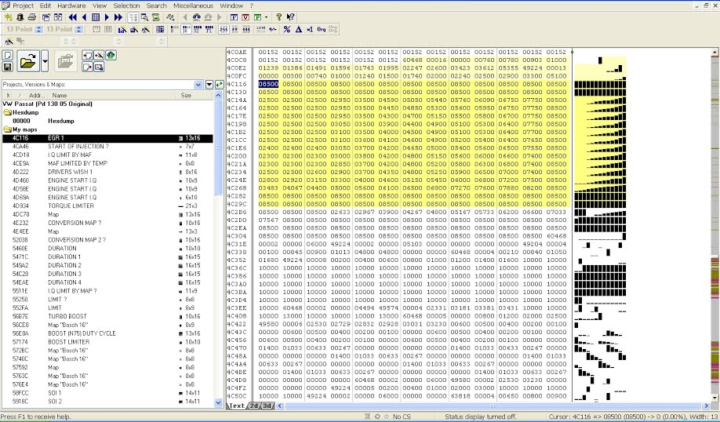

At this point it is worth checking the Winols set up. Winols should have automatically set some parameters for you according to the opened file. If you imported a 16 bit file, 16 bit button will be highlighted on the toolbar. If the hexdump opened in hexadecimal (FFFF, 1C2A etc) the FF button will be highlighted. If you prefer counting in Tens, click the 255 button to highlight it and get a hexdump like the one shown above.

Check the format that the hexdump was assembled in. (HILO or LOHI). You can see this on the button under the green “P” button. The example below shows LOHI.

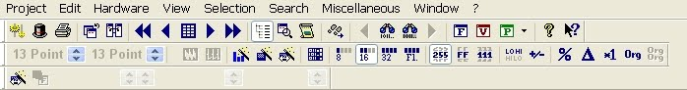

*Don’t forget this 16 bit and 255 detail.. It may trip you up later if you don’t watch out for it. (See Map properties pop up).*

You can now click on any auto discovered potential map in the left hand window. A 3D image of the potential map will open. It will be in a new pop up window. This has been resized to fill the whole right hand window in the picture below.

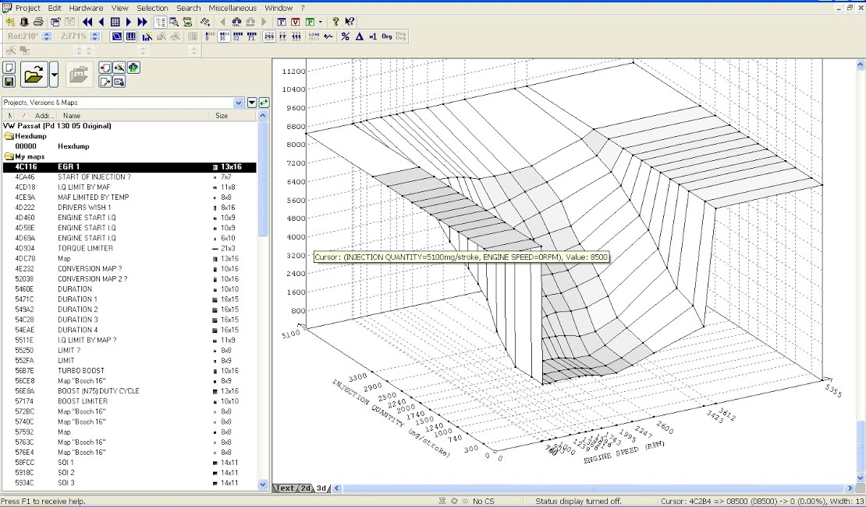

At the bottom of the picture you will see: Text, 2D & 3D. If you click Text, the image will change to text as shown below.

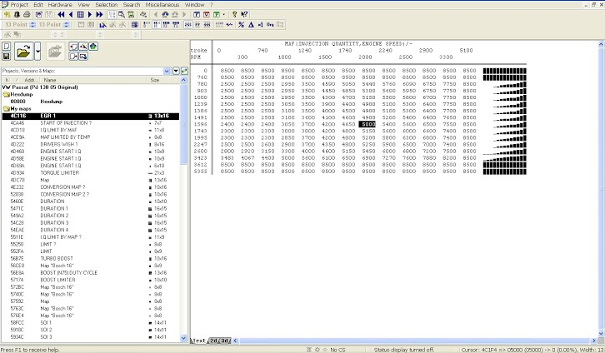

If you click 2D, the image will change to a line graph as shown below.

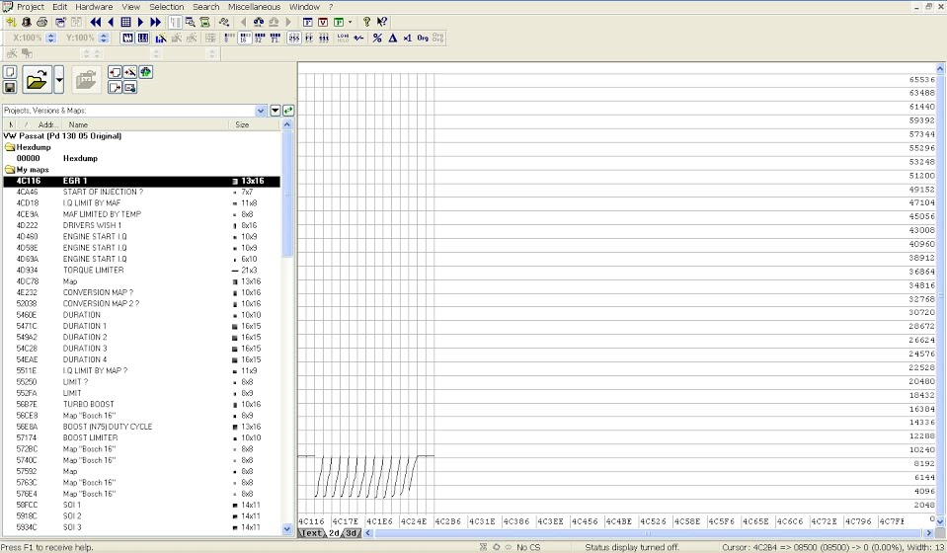

As a beginner it is easier to identify any obvious 3D maps and so you may want to stick with the 3D view until you learn to recognise a few maps.

If you close a map (Red X) you will be asked if you want to add the map to “Your maps”.  If it’s one you want to keep, Name it and click Yes.

To name your map. Double click the map to open the “Properties” pop up. You will see a box called “Name”. It probably has a name like Bosch 16 bit. 8 x 10. Change this to a name that suits you.

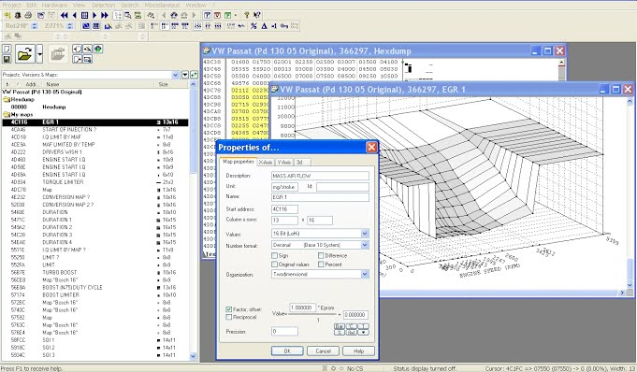

The rest of the properties for the map depend on how good you are at recognising the map. The one shown in these pictures is the Mass Air Flow map. Often called EGR map.

If you are familiar with “2D graphs, the 3D map may be a bit confusing. Winols doesn’t highlight the X and Y axes in the hexdump. It highlights the Z axis figures.

This can be confusing because the 3D map will always contain the highlighted Z axis numbers but the X and Y axis numbers can be missing.

When this happens, winols uses 1, 2, 3, 4 etc on the axes for X and Y. Even if the X and Y axes are correctly numbered, it is likely that they will not make any sense when you first see them.

With luck, Winols has automatically entered numbers onto the axes. These should be FIVE digit numbers. Eg. 12345. This poses a new problem.

12345 could 1,2345 rpm for engine speed.

12345 could be 12.345 % for duty cycle.

12345 could be 12.345 grams per stroke for mass air flow.

12345 could be 12.345 grams per stroke for fuel Injected Quantity.

12345 could be 12.345 degrees of Crankshaft Rotation for injection Duration or injection Advance.

If the map is a well known one, you may recognise it and be able to look up what the axes should be.

E.g. The EGR map will be.

* X axis: Injection Quantity in milligrams per stroke.
* Y axis: Engine speed in RPM
* Z axis: Mass Air Flow in milligrams per stroke.

The first “map properties” page (shown in the picture above) is for title and Z axis so the Z axis details go here.

You can see that I have entered

Description: INJECTION QUANTITY

Unit: mg/stroke

Data source, start address, values, number format, signature byte etc are usually automatically entered by Winols.

*This is where auto entry can trip you up…..see later comments.*

At this point the mg/stroke values on your Z axis are still based on FIVE digit numbers like; 10000, 11000 etc

The mg/stroke scale should read mainly “hundreds” so 9000 on the Z axis is actually 900 mg/stroke. NOT 9000.

I haven’t bothered to correct this in the picture below so it reads 8000, 9000, 10000 etc. To correct this. Go to the “Factor” box which reads 1.00000 and change the value to 0.1. This will change 8000, 9000, 10,000 into 800, 900, 1000 etc.

*Don’t touch the “offset” box. You will need to change that for some values, but not this one.*

So now you can go through the “Properties” pop up and fill in the details for Map properties, Z axis and name.

Check to make sure that the Values box is the same as the main toolbar setting.. “16 bit LOHI” in this example.

Check the Number format box is the same as the main toolbar setting. “Decimal (Base 10 system)” in this example.

Then complete the X - axis details as below.

Again I haven’t bothered to change the factor for mg/stroke. It should read 3, 4, 5, 6 etc not 300, 400, 500. So you might want to change the factor to 0.01.

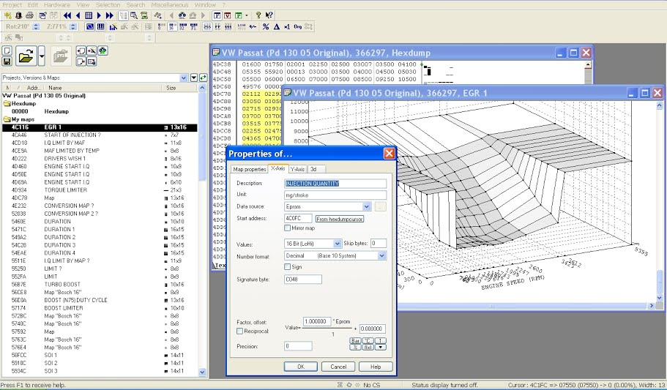

Then the Y axis details as below. (Factor can stay as 1.0).

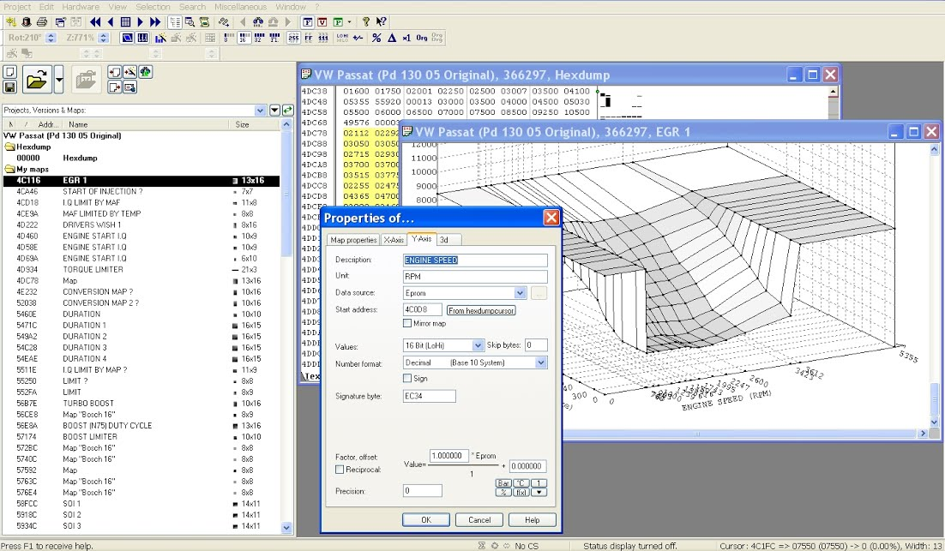

If your map looks exactly how you expect in terms of shape, axes labels, axes scales then you have finished one map.

Click OK.

*Sometimes when you click ok the map becomes a complete mess. Don’t panic. It means something is wrong in one or more of the properties. Just open the properties popup and search for your mistake.*

## Finding MAP in WinOLS Manually

Winols cannot identify all maps automatically. It often finds some good obvious ones, some useless ones and some that are not maps at all. For this reason it is a good idea to learn to search for them your self.

Open Winols as usual and open your project. Change the hexdump view to 2D. Use the direction arrows to scroll through the 2D file. You are looking for a potential map like the one highlighted in YELLOW below. It won’t be highlighted in yellow….life isn’t that simple.

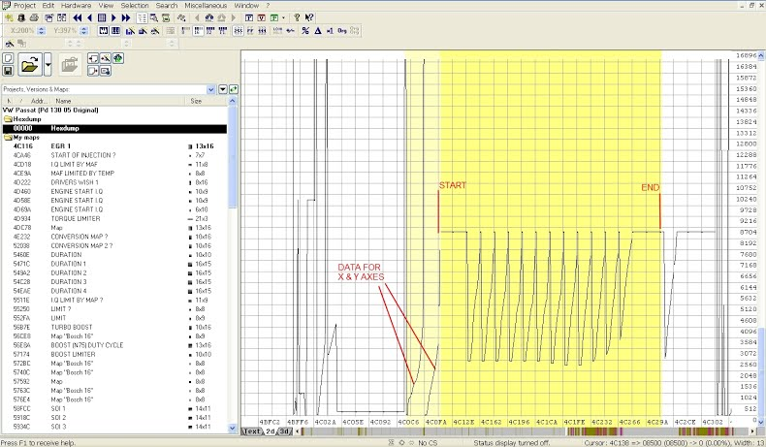

Take your best guess at the beginning and end of the map. This one has a wide bar at each end.

Using your keyboard, hold down Ctrl key and press left or right direction key. You will see the grid behind the trace, move. Move the grid until a vertical line, lines up with any trace point.

You can line the grid up with the start of the trace, at the point (top), or at the end of the trace. It doesn’t matter.

The object of this game is to get a vertical line to line up with each trace point, just like on the picture above.

Press “w” to move the grid lines closer together.

Press “m” to move the grid lines further apart.

Every time you use “w” or “m”. Remember to move the grid to keep your original vertical line in the same place.

Eventually you will find a point where each trace point has a grid line matched with it.

What you are trying to do is produce a set number of columns. In the picture above you can see 16 columns.

(Ignore the two faint yellow ones on the left).

Use the mouse to click on the left side start of your map and drag across to the right side end of your map.The map will be selected as grey and white stripes.

Now switch to Text view.

If everything has worked perfectly it will look like the picture below. Instead of being YELLOW, the highlighted bit will be GREY.

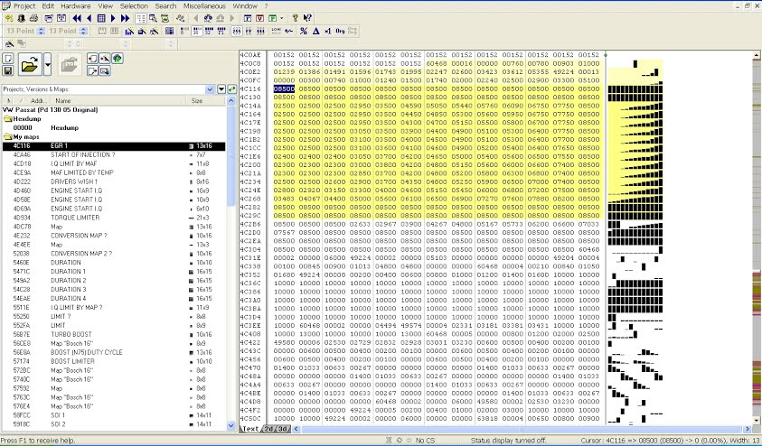

Now go to the top taskbar and select Window > Preview. A new window will open showing your selected map.

If nothing happens, your selection is no good or Winols is playing up (It does that).

You can leave the Preview window open all the time if you want. OR just call it up when you want to look.

If the preview, looks like a map, click anywhere on the selected area. Press “k” on the keyboard and this will turn your selection into a map. The map will appear in a new window in text form with the usual text/2D/3D options. If you change to 3D view it will look like the “preview” window.

Click the RED X on the box and it will automatically be saved in the “My maps” section in the left window.

Sometimes when you change from the 2D view to the text view you don’t get a perfect rectangle block of text. If this happens, something is wrong with your selection.

You just play the same game again in text view. “m” key will give you more columns and “w” key will give you less columns.

Ctrl left arrow and Ctrl right arrow will move your selection on the grid.

A good tip is to look at the numbers in each row. Look for any kind of pattern. In the selection above you can see that the top and bottom row cells are all 08500. So it is obvious when you have the selection lined up properly.

Here are some typical 2D map shapes to help you search in 2D.

### EGR

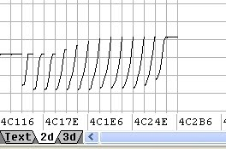

### DRIVERS WISH

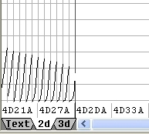

### TORQUE

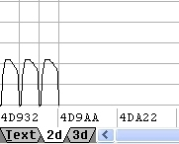

### N75 DUTY CYCLE

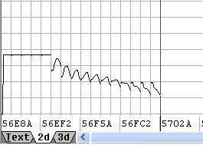

### TURBO BOOST

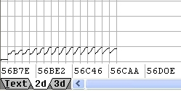

### BOOST LIMIT

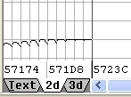

Lots of the other maps just look like flat lines in a 2D view unless you zoom the view. That makes Duration and Start of Injection etc, harder to find.

## Single Value Boost Limit (SVBL)

In some Hexdumps, this is found just before the Hexdump address 32043 or 31455. To find it click “Search” on the toolbar followed by byte sequence/text. Set the data tab to decimal and type in the address. E.g. 32043.

Press Right Arrow. You will either get sent to the correct address or get a message saying “not found”. If the address is found, the SVBL should be the box in front of 32043. A typical VW turbo figure is 2350 so it will read 02350.

If 32043 doesn’t work, try 31455. If neither 31455 or 32043 work, you will have to search in 2D mode.

First use the Hexdump to find your boost limiter map. e.g.

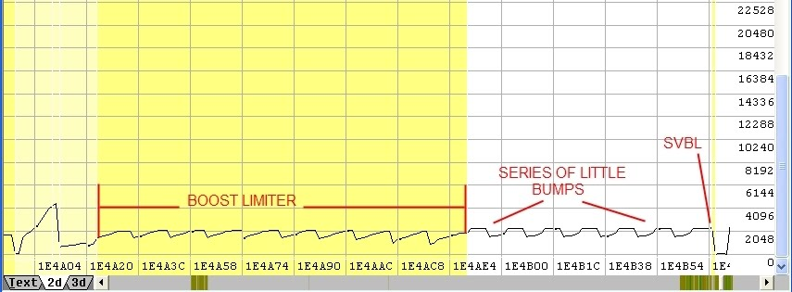

Find the end of the Boost limiter map. (It’s easier to find the end in TEXT view). This will be followed by a series of little bumps as shown above. The highest point of the last little bump is the SVBL. In the example above, the little bumps are all 2250 but the last one is 2350. That is the limiter.

If none of these methods work, you may have to ask on a chip tuning forum.

### HELP MY AXES ARE MISSING!!

Winols automatically finds map axes data when the data is in an obvious place. E.g. just before or just after a map. So when you manually find a map, you may be lucky and Winols will spot the axes data and enter it for you.

If Winols can’t find the map axes data it simply uses 1, 2, 3, 4, 5 etc for the axes. This means you will have to find the map axes data and tell Winols where the data is.

### FINDING MAP AXIS DATA AND ADDING IT TO WINOLS

Lets assume you are looking at a 3D map with X and Y axes that both say 1, 2, 3, 4, 5, etc.

You need to switch back to the hexdump which will have the map highlighted in grey or yellow. Count the number of columns and rows. EGR 1 in the picture above is 13 columns by 16 rows and is shown in the left hand window as 13 x 16.

This information is hiding in the hexdump. 13 will be 00013 and 16 will be 00016. Sometimes the numbers 00013 and 00016 will be next to each other and sometime not.

The main clue is the number of cells. E.g.

|  |  |  |  |  |  |  |  |  |  |  |  |  |
| --- | --- | --- | --- | --- | --- | --- | --- | --- | --- | --- | --- | --- |
|  |  |  |  |  |  | 60468 | 49224 | 00016 | 00013 | 00000 | 00700 | 00800 |
| 00840 | 01000 | 01239 | 01386 | 01491 | 01596 | 01743 | 01995 | 02247 | 20499 | 02750 | 03423 | 03612 |
| 00000 | 00300 | 00740 | 01000 | 01240 | 01500 | 01740 | 02000 | 02240 | 02500 | 02900 | 03300 | 05100 |

00016 and 00013 are followed by 16 cells from 00000 to 03612 and then 13 cells from 00000 to 05100. Because 00016 and 00013 are next to each other they are easier to spot.

It is harder when the Axes pointers are not next to each other. E.g.

|  |  |  |  |  |  |  |  |  |  |  |  |  |
| --- | --- | --- | --- | --- | --- | --- | --- | --- | --- | --- | --- | --- |
|  |  |  |  |  |  | 60468 | 00016 | 00000 | 00700 | 00800 | 00840 | 01000 |
| 01239 | 01386 | 01491 | 01596 | 01743 | 01995 | 02247 | 20499 | 02750 | 03423 | 03612 | 49224 | 00013 |
| 00000 | 00300 | 00740 | 01000 | 01240 | 01500 | 01740 | 02000 | 02240 | 02500 | 02900 | 03300 | 05100 |

00016 is followed by 16 gradually increasing numbers from 00000 to 03612. The next cell is 49224 which obviously doesn’t follow the previous pattern. 00013 is followed by 13 gradually increasing numbers from 00000 to 05100.Because 00016 and 00013 are not next to each other, they are harder to find.

The section with 00016 and 00013 may be before or after the map you are looking at.Sometimes there may be 10 similar maps, all with the same axes. (Start of Injection maps are grouped like this.)

 The axes data may be **well before** the first map or **well after** the last map so don’t just look next to the maps.

Surprisingly, a good clue is in the 2D view. The axes data will often look like Two spikes well before or well after the map data block.

### HOW DO YOU ADD THE AXES DATA TO WINOLS

On the “hexdump”, Click on the first cell for the axis data you want. E.g. 00000 after 00016 in the table above. You must do this so Winols can find the cursor.

Double click the 3D map to get the Properties box. Choose “Y axis” tab.

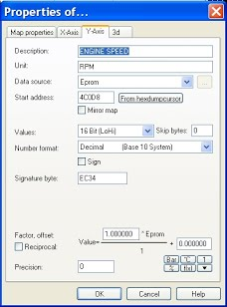

Data source will currently display 1, 2, 3, 4, 5 etc. and start address will be “greyed out”.

Click data source and change to “Eprom”.

Start address will be “zero”.

Click “From hexdumpcurser”.

Set “Values” to what ever is on the main “Map properties” page. (E.g. 16 bit HILO).

Click “ok”.

Go back to the hexdump.

Click on the first cell for the axis data you want. E.g. 00000 after 00013 in the table above.

Double click the 3D map to get the Properties box.

Choose “X axis” tab.

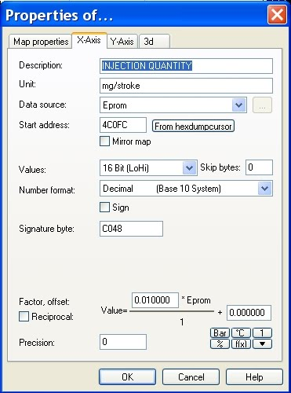

Data source will currently display 1, 2, 3, 4, 5 etc. and start address will be “greyed out”.

Click data source and change to “Eprom”.

Start address will be “zero”.

Click “From hexdumpcurser”.

Set “Values” to what ever is on the main “Map properties” page.

Click “ok”.

Now your map should have the correct axis numbers displayed for X and Y.

You will still need to change “Description”, “Unit” and “Factor” if you haven’t done it yet.

### UNDERSTANDING FACTOR AND OFFSET

The factor just tells Winols where to put the decimal point in the numbers. The numbers on the axes will be based on FIVE digit numbers. Eg. 12345 in 16 bit mode, decimal view. But will often appear as FOUR digit numbers. E.g. 4000.

You need to know what the axis data represents before you can work out the Factor and Offset.

E.g. 4000 may be 4000 rpm in which case the Factor can be left as 1.000000 and offset left as 0.000000.

4000 may be 4000 mg/stroke in which case the factor might be 0.1 for Mass Air Flow at 400.0 mg/stroke or the factor might be 0.01 for Injection Quantity at 40.00 mg/stroke.

Offset remains as 0.000000.

4000 may be % so again the Factor will be 0.01 and offset 0.000000.

4000 may be Temperature.

Scientists measure temperature in degrees Kelvin (°K) and so do ECU programmers. If you read temperature in degrees Kelvin then you just need to set the Factor to 0.1 and 4000 becomes 400°K.

Most of us read temperature in degrees Celsius so we need a conversion “offset”.To convert from °K to °C you have to take away 273. So the offset is -273. and 400 becomes 400 – 273 which is 127°C.

You can often spot a temperature axis because it contains the numbers similar to 273, 263 and 253. These are 0°C, -10°C and -20°C.

One Factor that gives everyone a real headache is that for Degrees Crankshaft Rotation (°CR). This factor is used for Injection start and injection duration.

One clue to Injection start and injection duration is that the numbers may be 3 digit (400) rather than 4 or 5 digit. (4000 or 40000). This factor is 0.023437.

400 may be injection duration in °CR in which case the factor is 0.023437. So 400 will be 400 x 0.023437 which is 9.3748 °CR.

At this point things get more confusing. EDC15 ecu’s found on B5 passats measure Start Of Injection (SOI) as degrees After Top Dead Center. (°CR. ATDC) with a factor of 0.023437. This gives SOI figures on the map in the range 48 to 78 °CR. ATDC.

EDC16 ecu’s use the same factor (0.023437). The figures are Before Top Dead Center so the map range is 0 to 30 °CR. BTDC.

If you want the EDC15 figures to look more like EDC16 figures you use an offset of -78. This turns the 48 to 78 range into -30 to 0 range.

The figures are negative as they are ATDC. (Remember -30°CR. ATDC is the same as 30°CR. BTDC).

### PRECISION

To keep the axes tidy you might want to change 9.3748 to 9.3 or 9.37. You do this by changing the number in the precision box on the properties Window. This just tells Winols how many numbers to show AFTER the decimal point.

So 1.234 with a precision of “0” is 1, 1.234 with a precision of “2” is 1.23, etc.

## To help with MAP identification

Here are some common 3D maps found in VAG PD tdi hexdumps.

### DRIVERS WISH

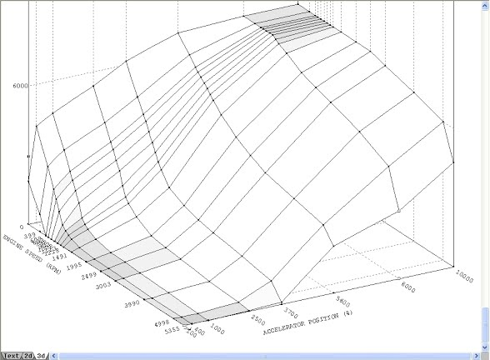

### INVERSE DRIVERS WISH

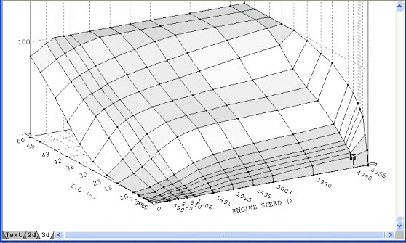

### EGR

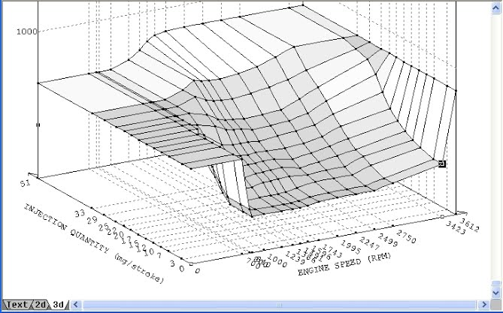

### I.Q LIMITED BY MASS AIR FLOW. (SMOKE MAP)

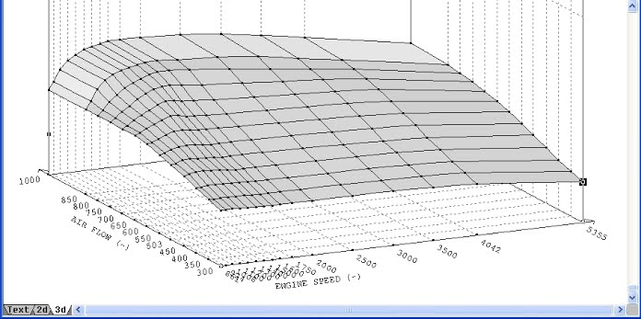

### I.Q LIMITED BY MANIFOLD ABSOLUTE PRESSURE (SMOKE MAP)

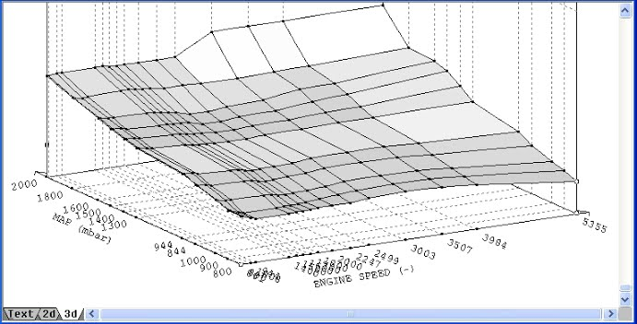

### TORQUE LIMIT

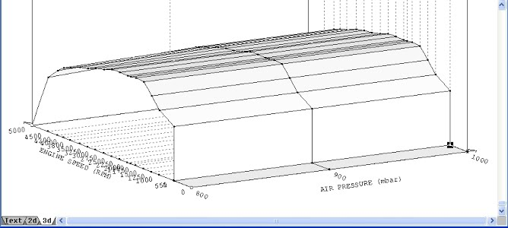

### DURATION MAP

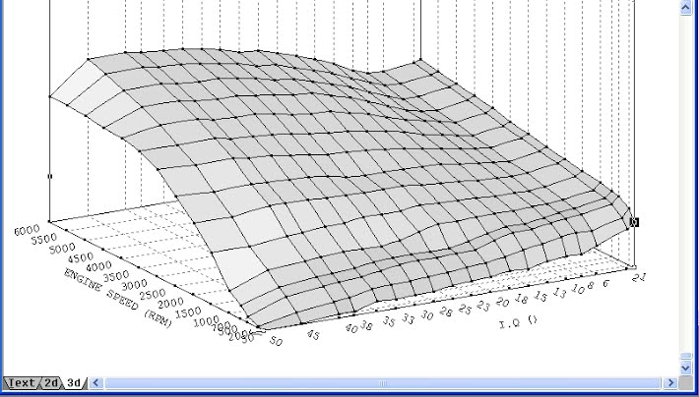

### START OF INJECTION

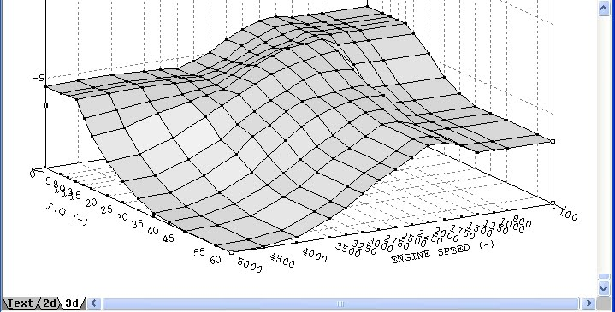

### BOOST DUTY CYCLE (N75) %

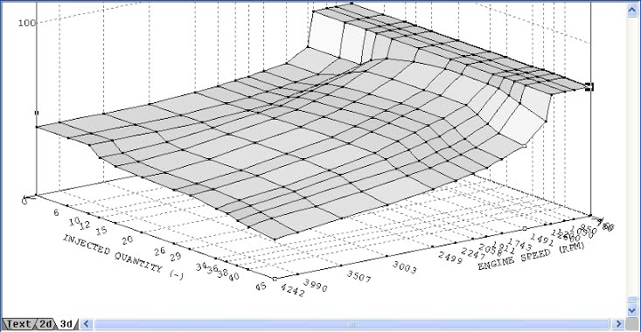

### BOOST MAP

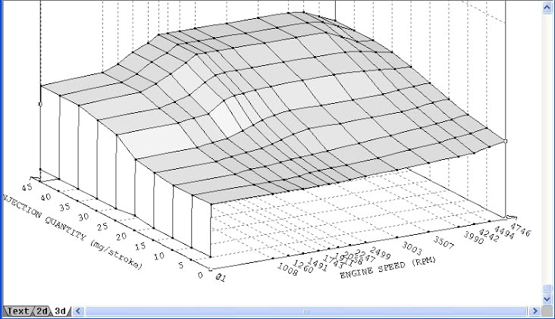

### BOOST LIMITER

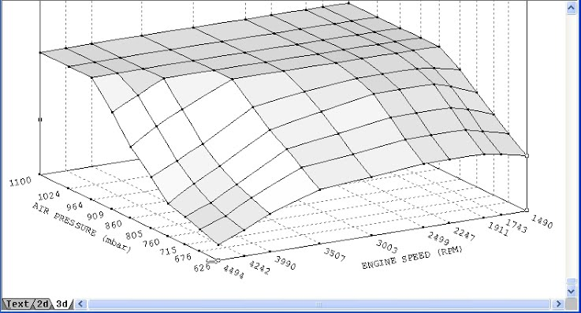

# Understanding ECU MAPS. Part 1

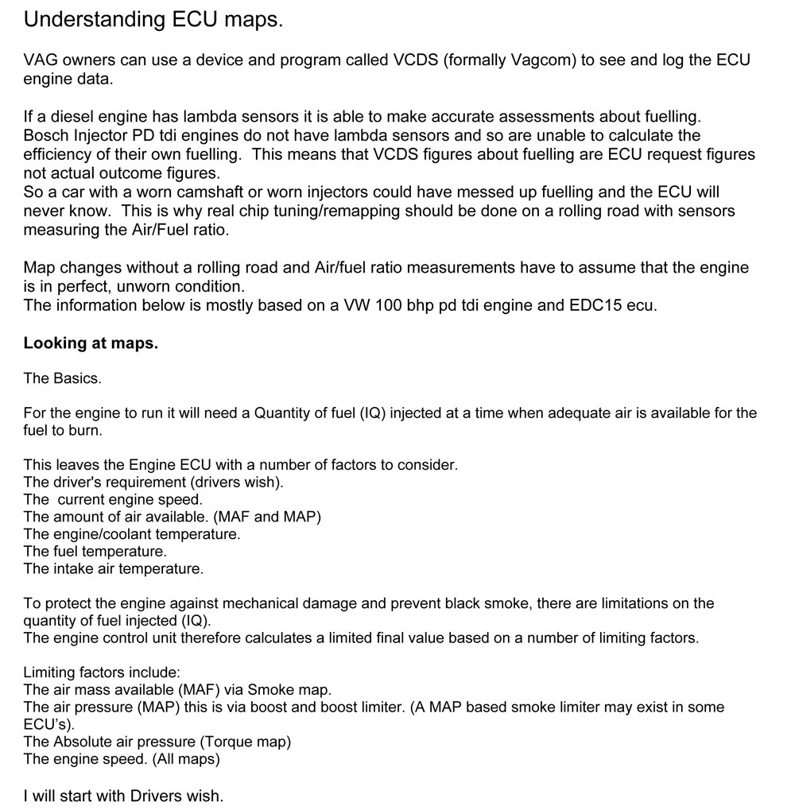

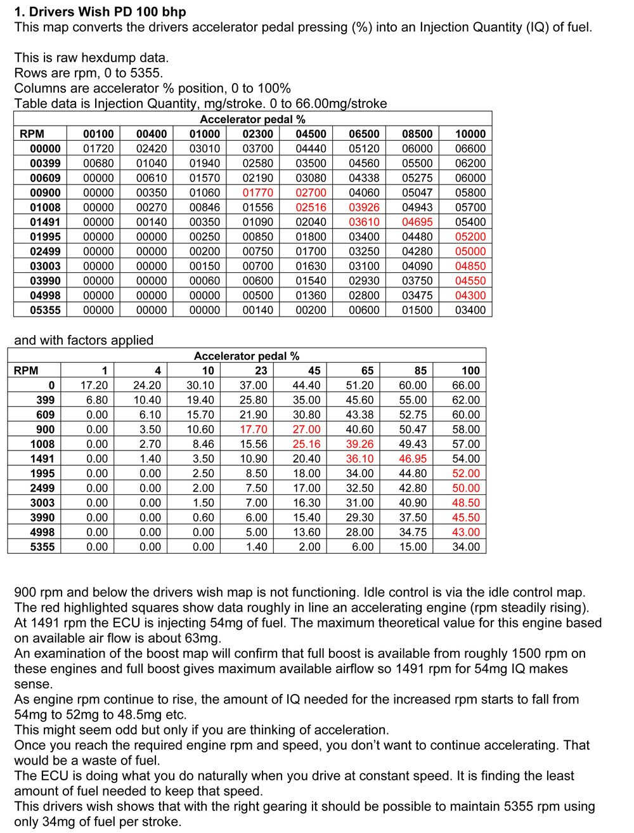

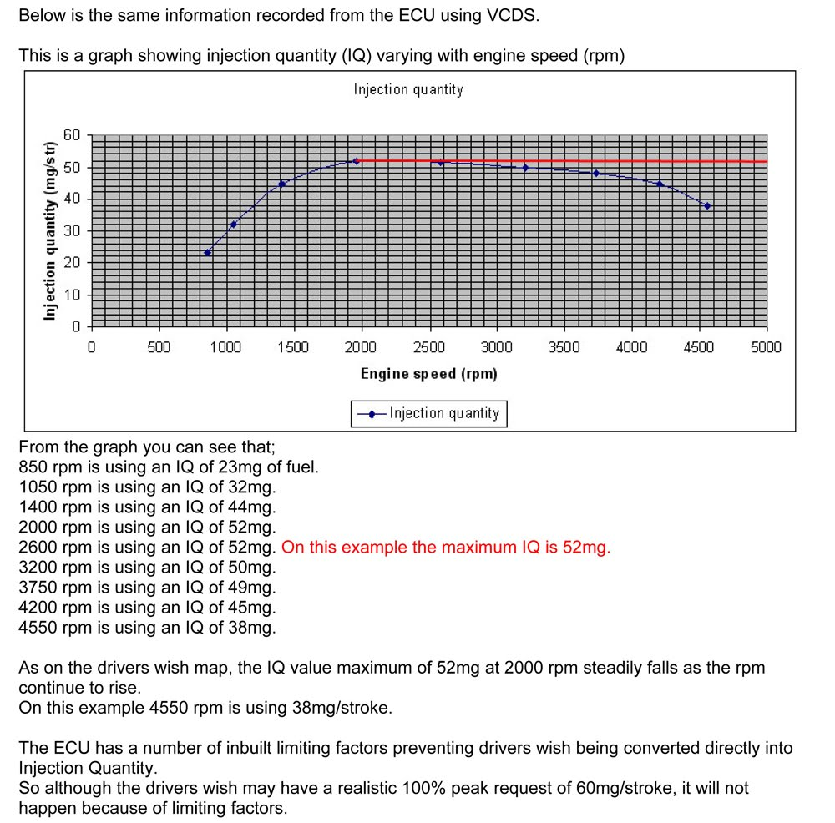

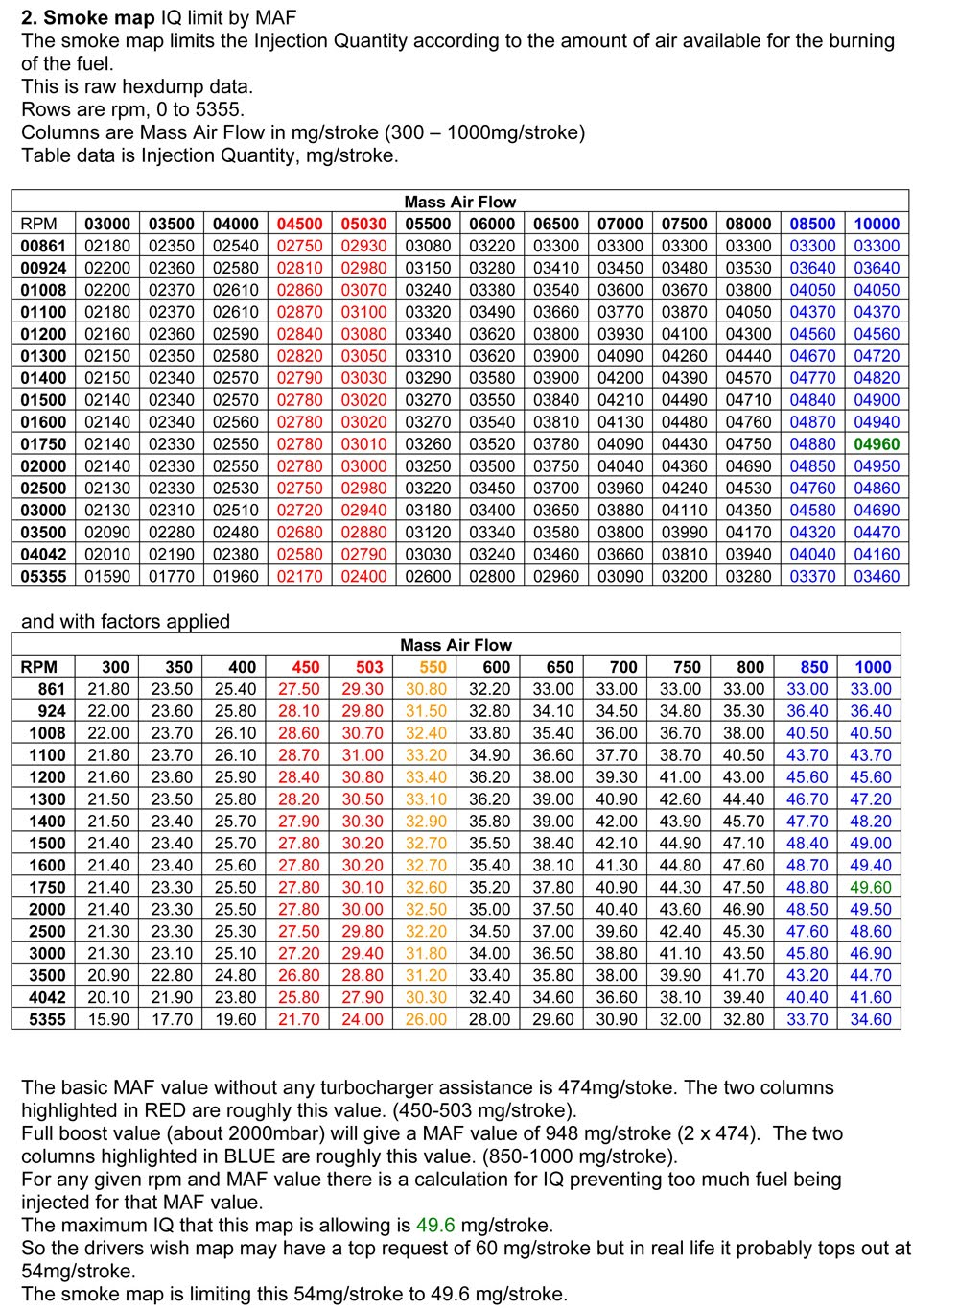

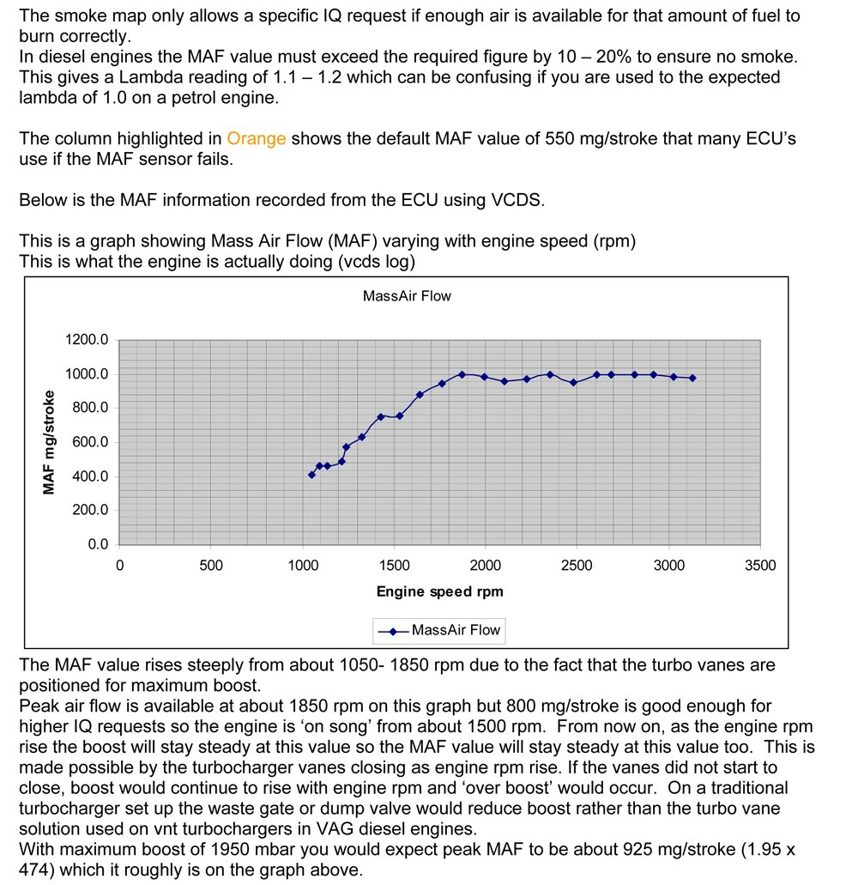

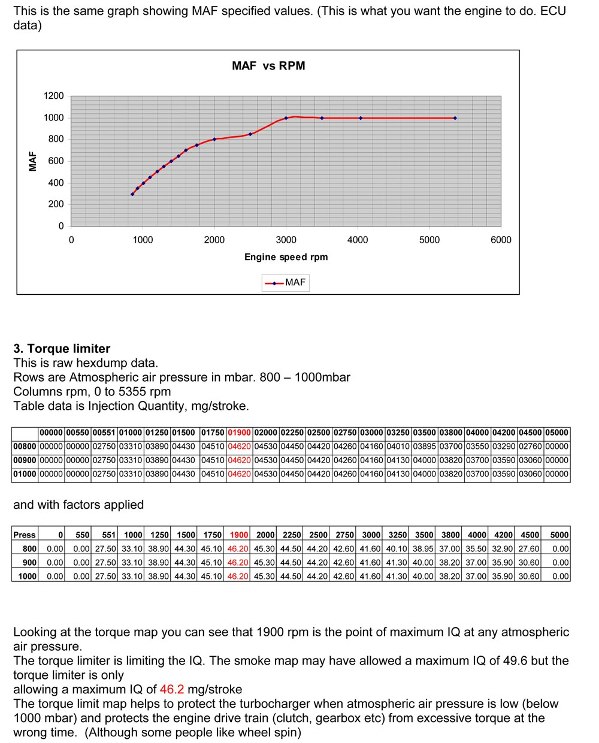

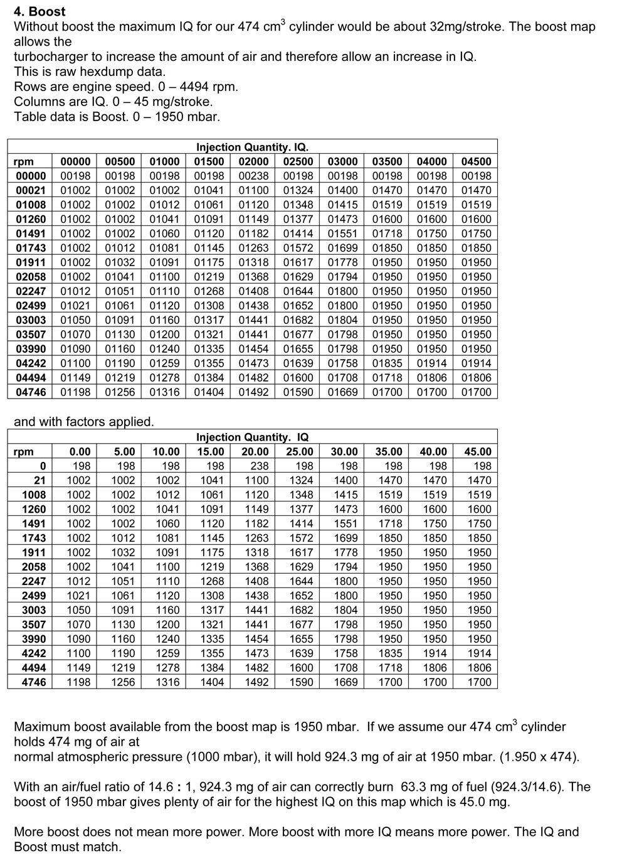

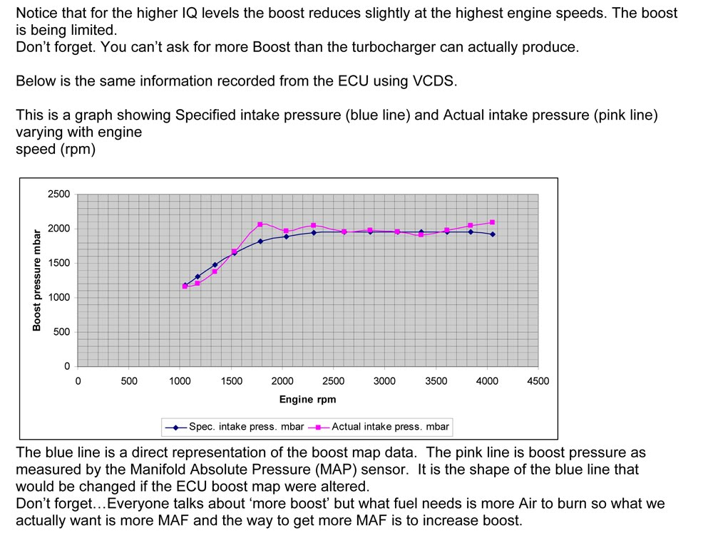

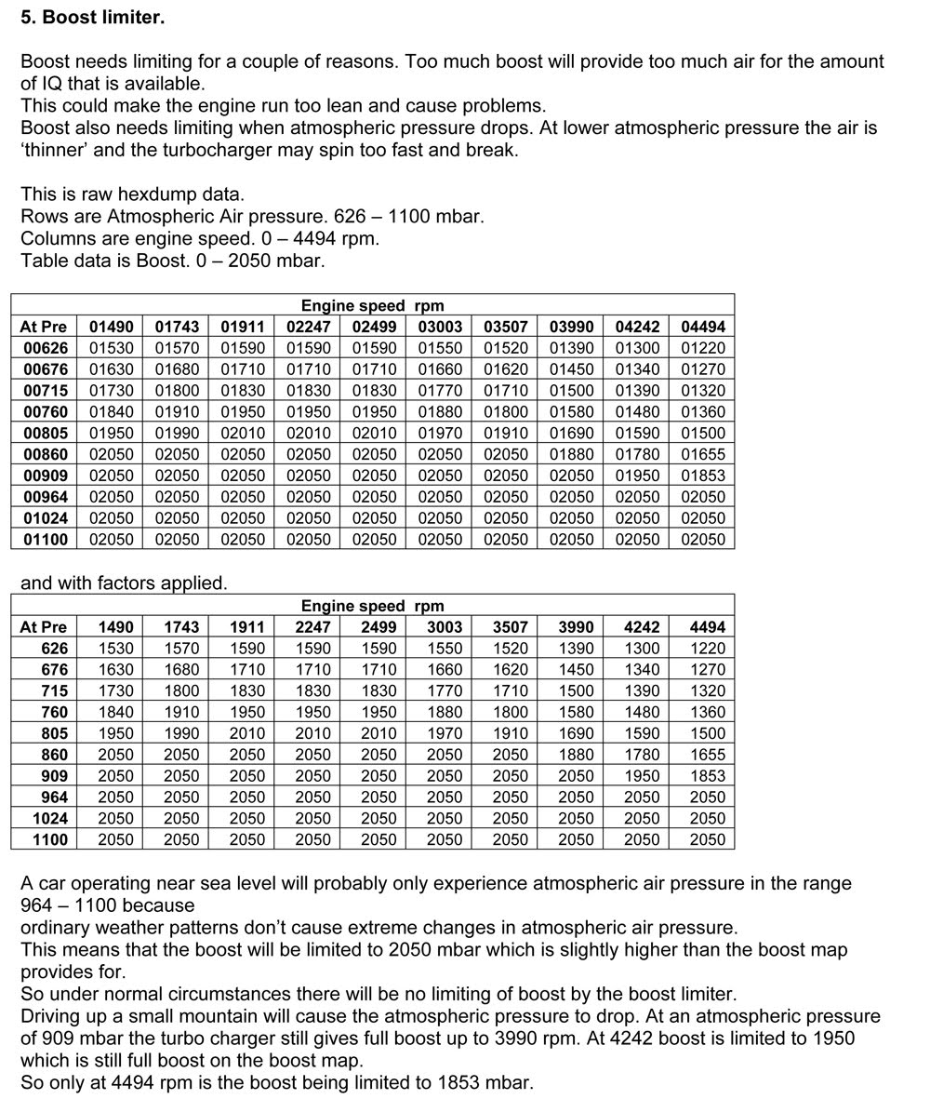

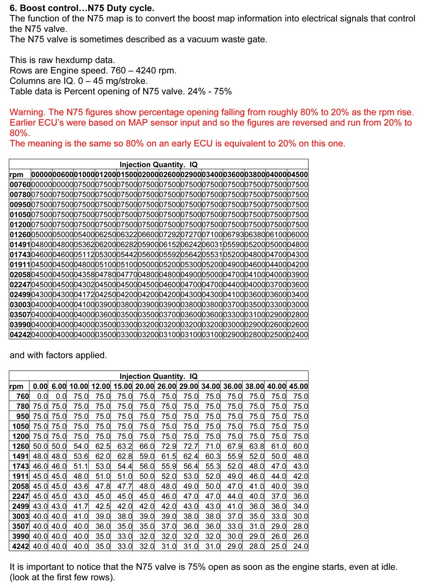

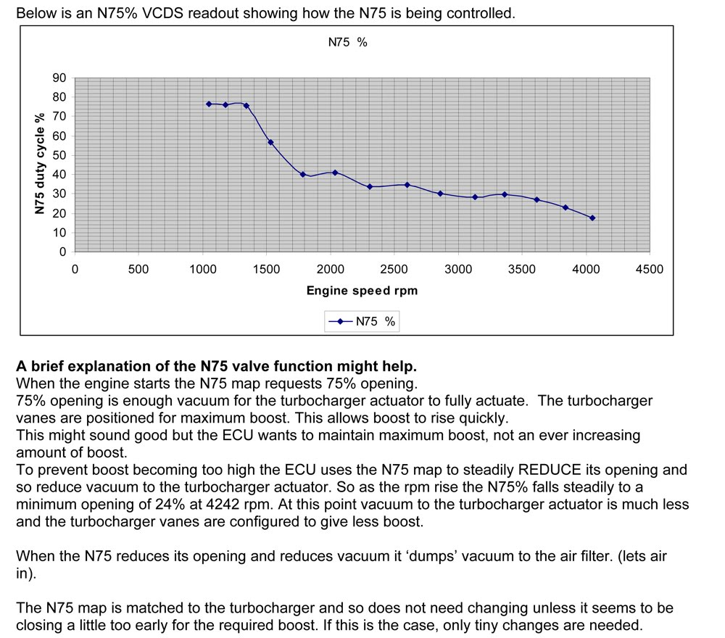

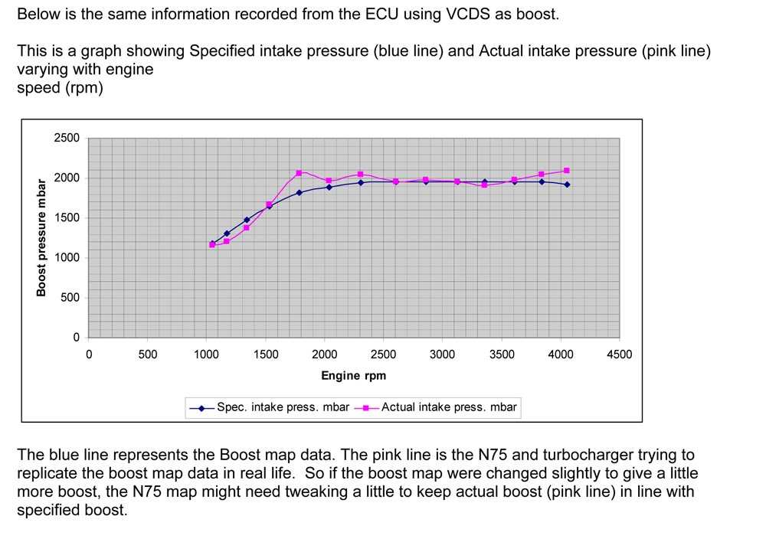

# Understanding ECU MAPS. Part 2

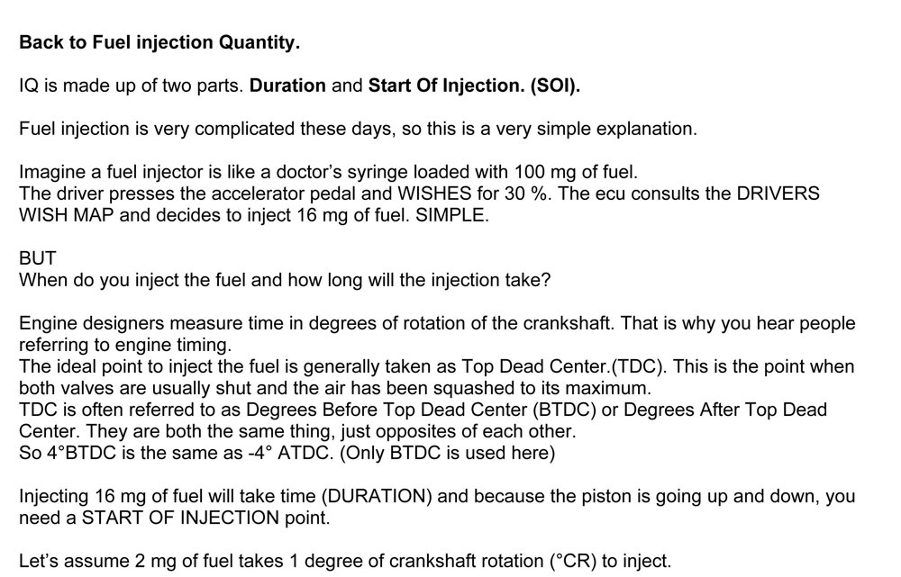

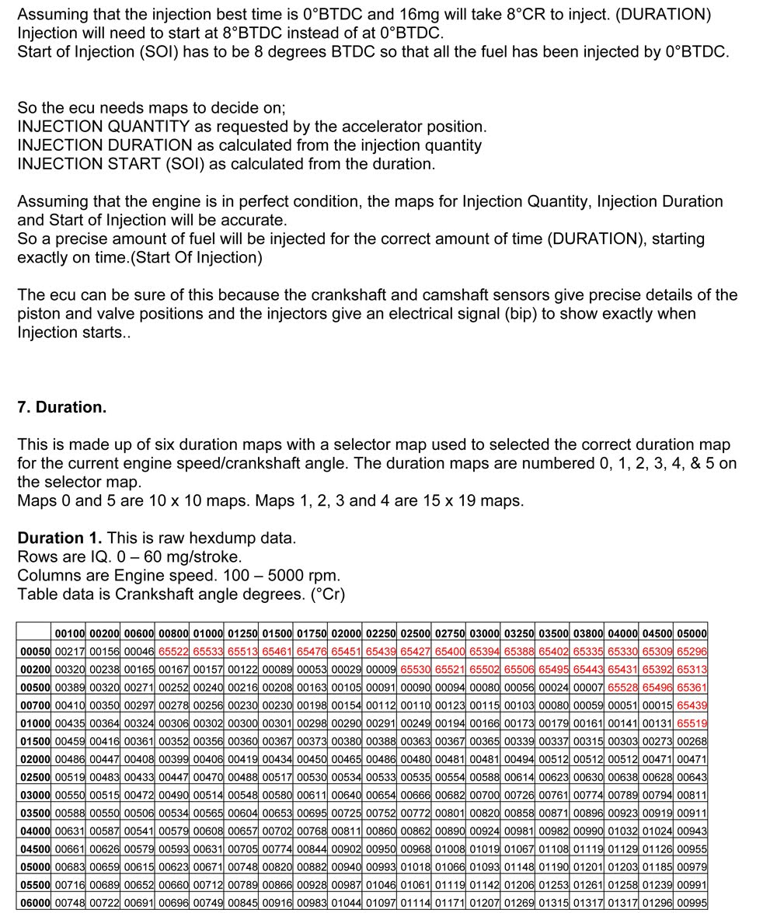

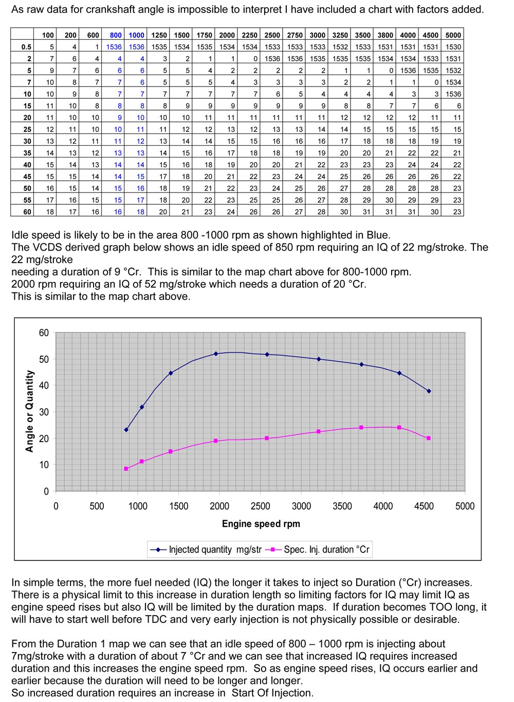

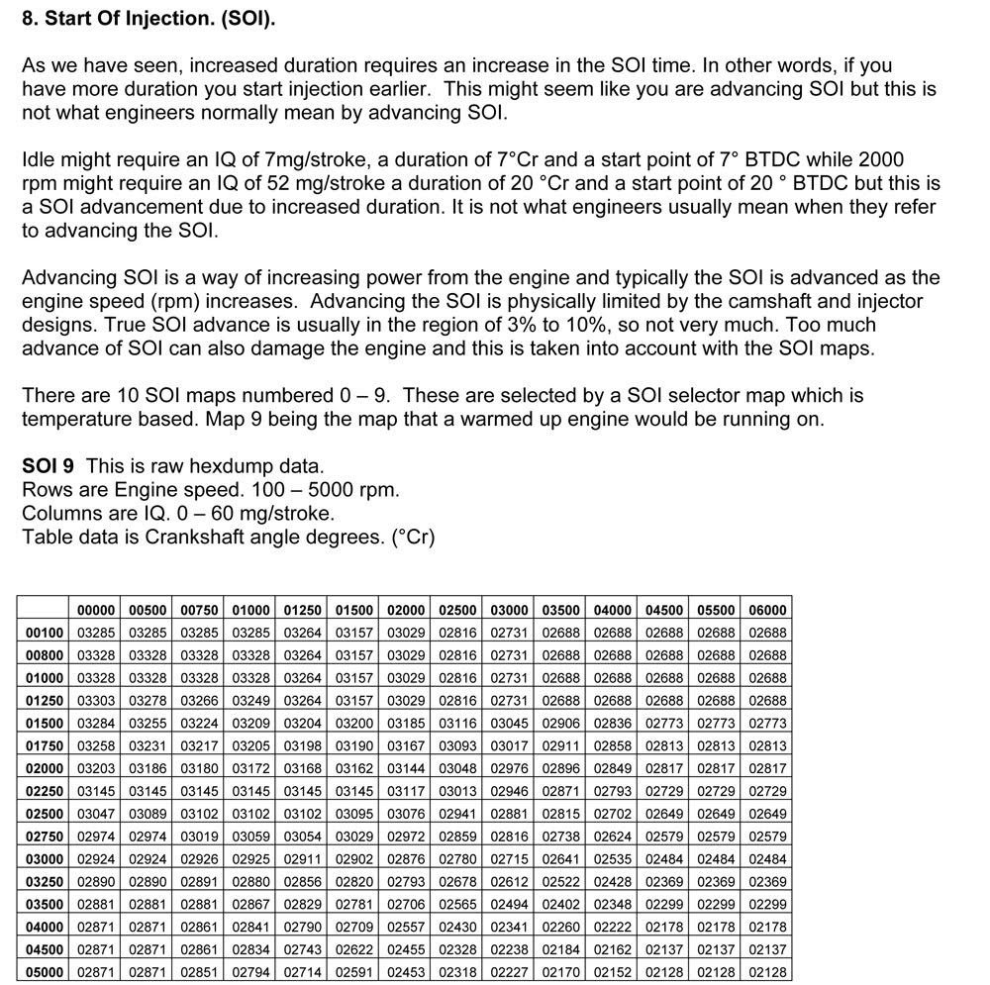

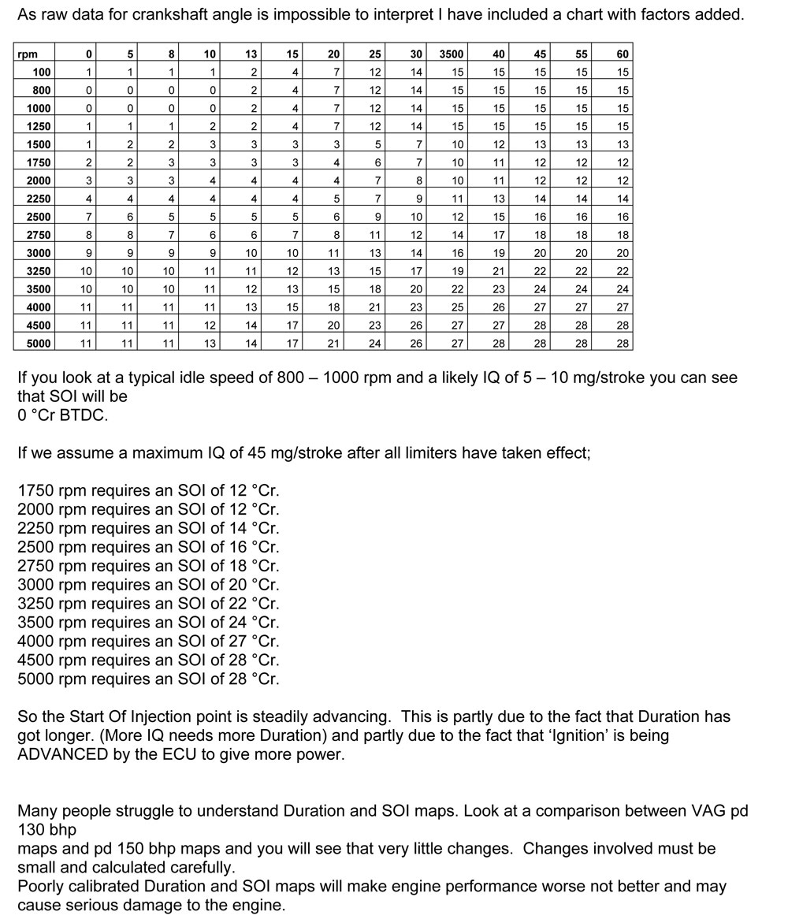

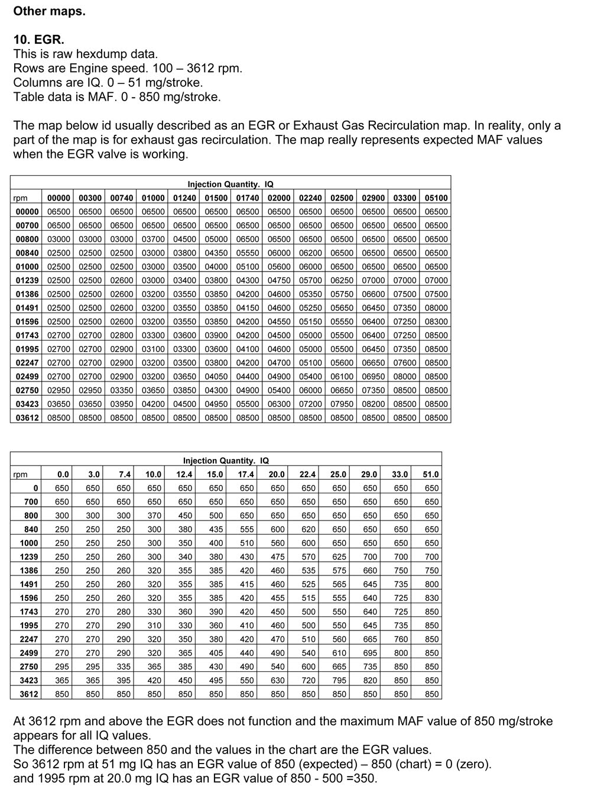

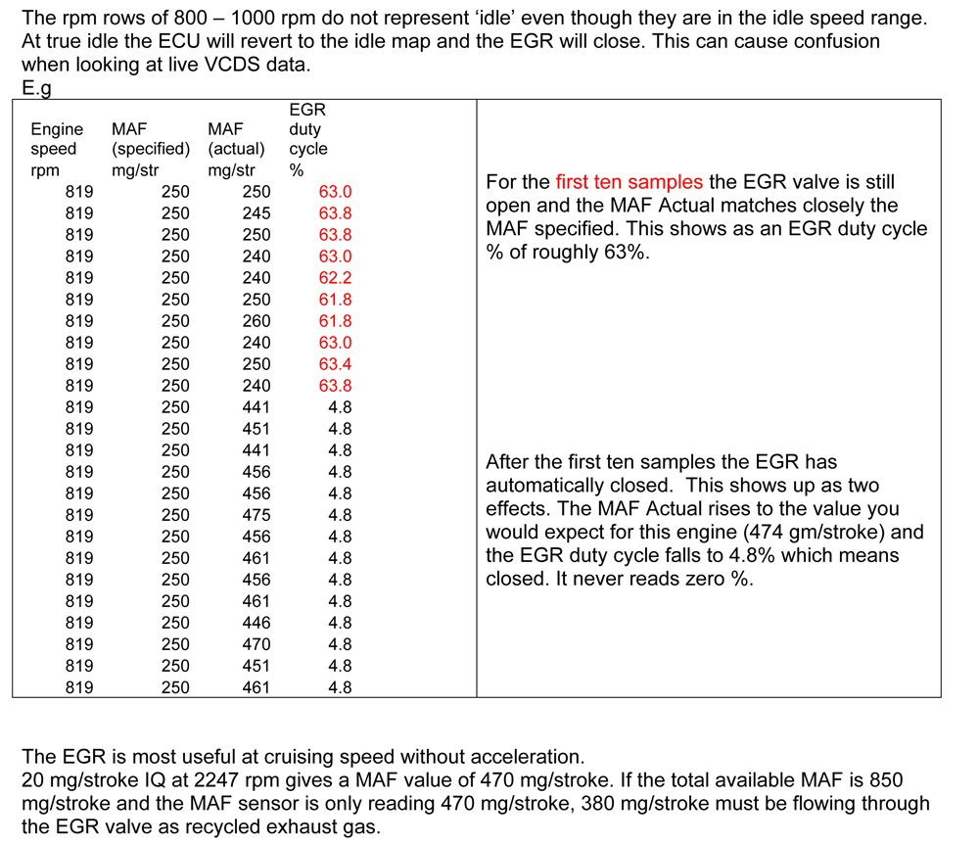

# WinOLS. Making MAP changes. EGR example

*Making changes to the ECU maps can be very dangerous to your engine, so be very careful.*

A common change that people want to make is to remove the Exhaust Gas Recirculation (EGR) function.

On Pre-PD engines it is easy to do mechanically by blanking the EGR pipe off or just pushing the valve shut and removing and closing the vacuum pipe that controls the valve.

If you do this on a PD engine you often get a fault code warning on the dash.

One way to delete the EGR function on a PD engine is to blank it off (you can just leave it shut) and remap the EGR map in the ecu.

Removing EGR function by changing the map can still lead to a fault code being flagged. If that happens , change the max settings to about 95% of max rather than 100%. That should prevent a fault code.

CHANGING THE EGR MAP. This is the best first change to attempt. If it goes wrong, you are not likely to damage the engine.

Hopefully you know how to find your EGR map in Winols. It looks like this;

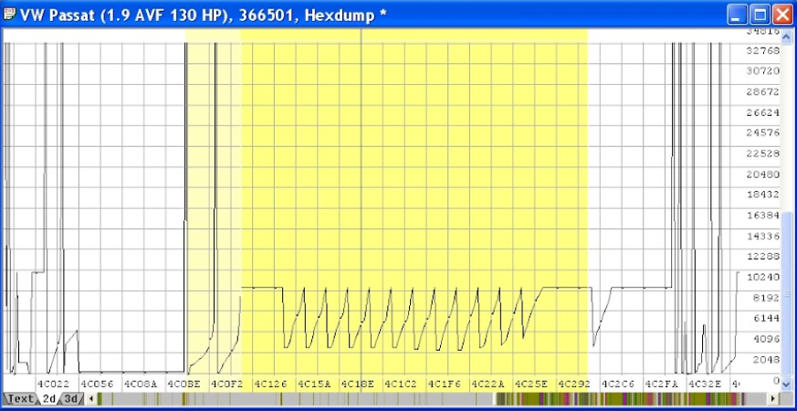

Click the “EGR” map on the main screen or click the “EGR” name in “My maps”.

This will show the EGR map pop-up window. It is shown in 3D view below.

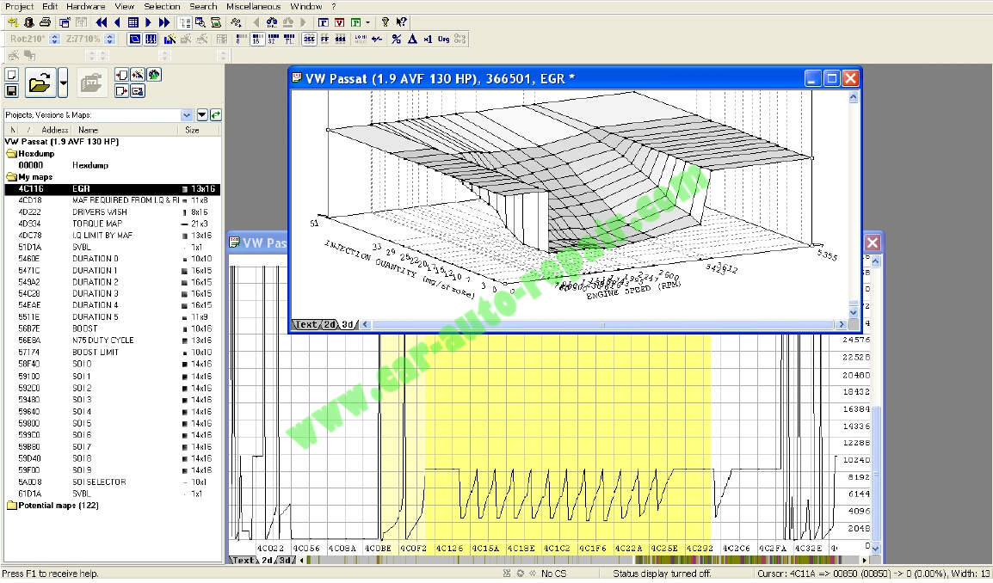

It will probably open in text view. If not, change it to text view so it looks like this:

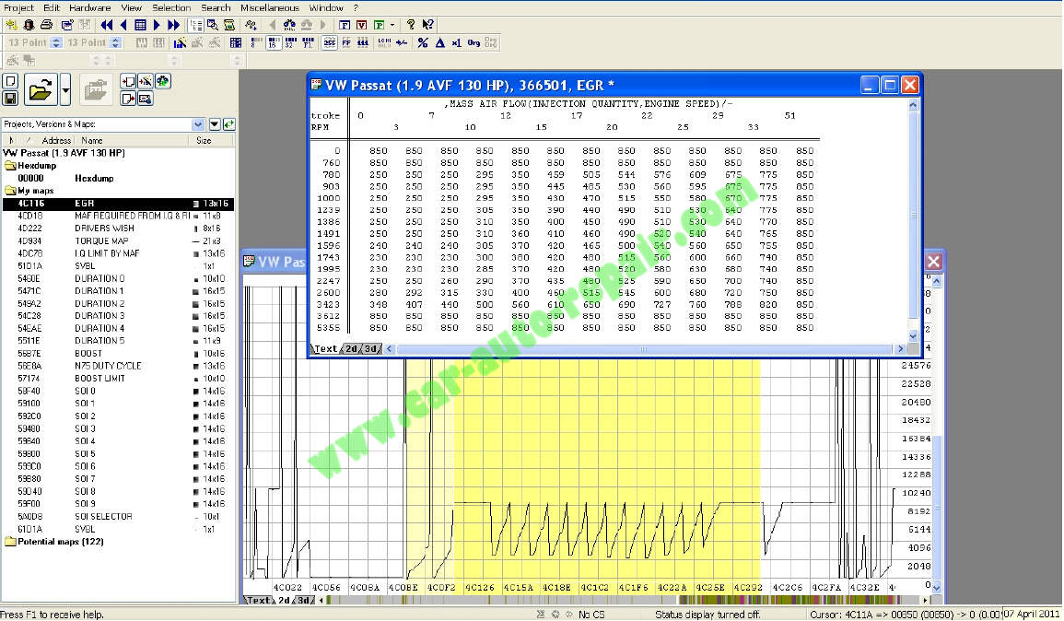

The text view numbers tell the ecu what it should be telling the EGR valve to do.

Look for the highest number. In this case it is 850. This “highest” number tells the EGR valve to stay shut.

You want to change the whole map, so every number is 850. That way the EGR will stay shut and not recirculate exhaust gases.

To change the values, click and drag to highlight them all.

E.g.

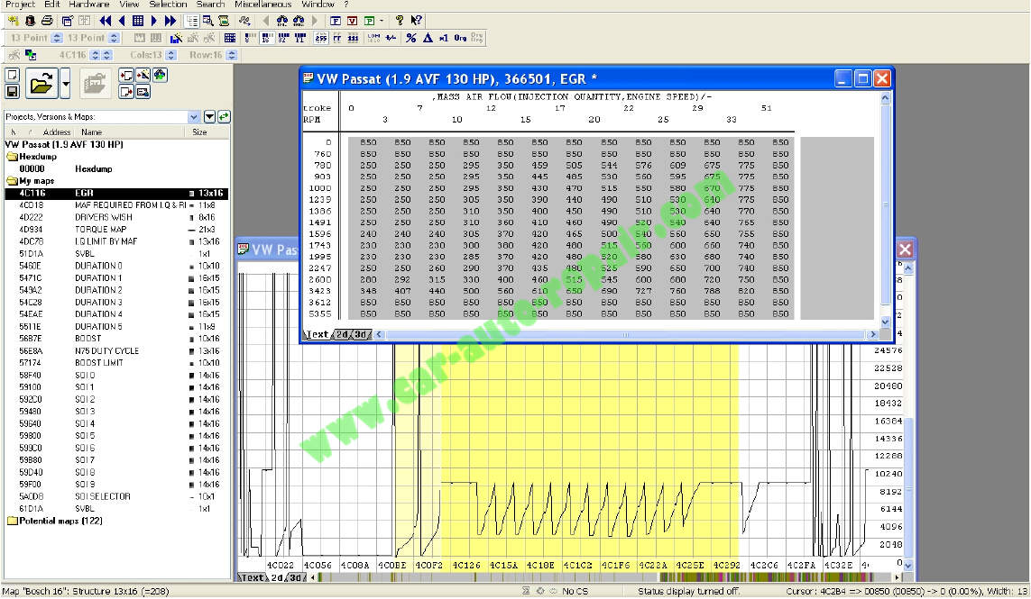

With the numbers highlighted, go to the toolbar, click “Edit” followed by “change absolute” (or just press the “=” key)

E.g.

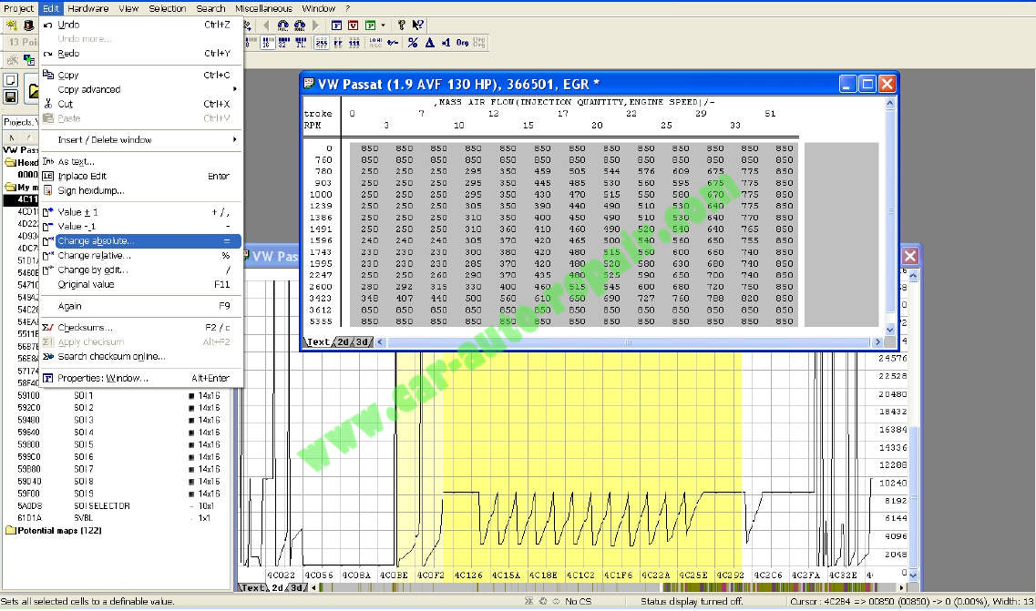

You will get a new pop-up window.

E.g.

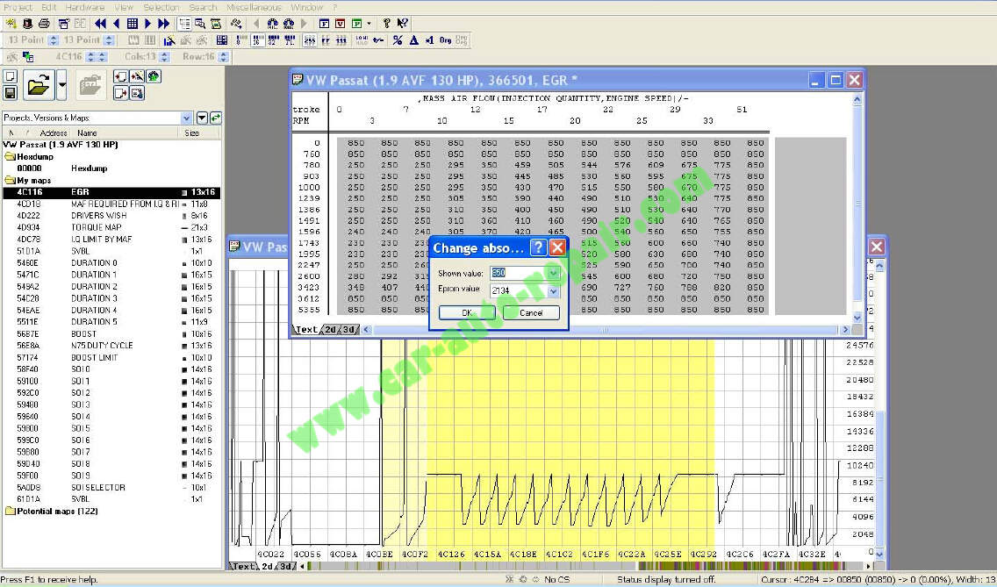

The pop-up will have “Shown value” highlighted. This is the first (top left corner) value of your highlighted selection.

It is likely that this is the number you want. If not, change the number to the highest value on the map. It is usually about 800-1000.

Once you have changed the number, click OK.

*At this point you may get a “warning” pop-up. If you do, choose the first option (switch off protection) and OK. If you don’t do this the changes won’t happen.*

The numbers will all change to your new number, 850 in this example. Numbers that were 850 anyway, will be black. Numbers that have been changed will be red.

E.g.

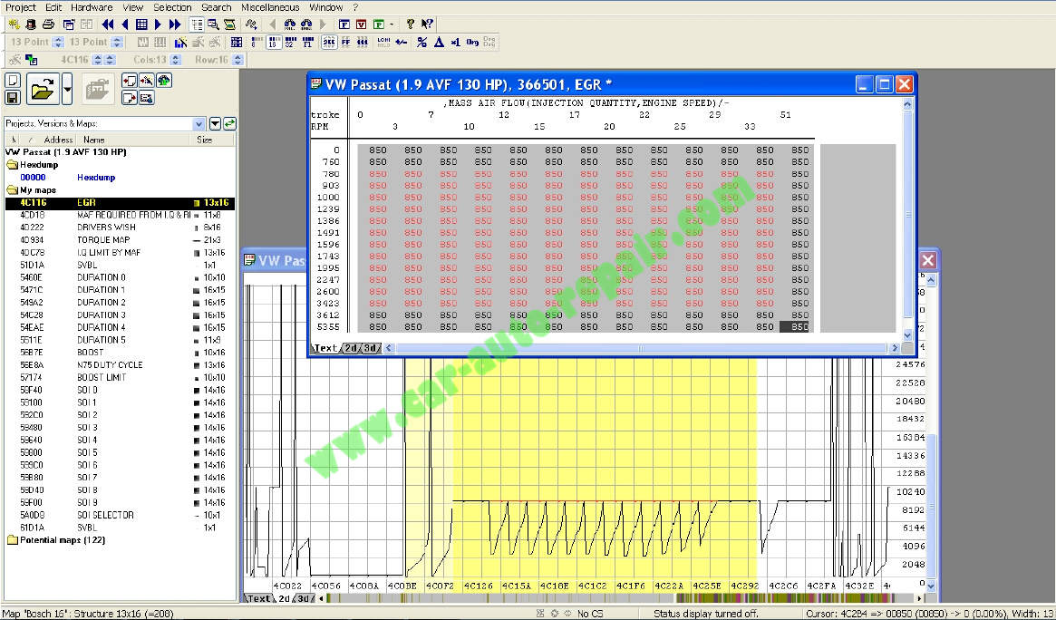

If you switch to 3D view you will see that any original values on the graph are black and the changes you have made are red.

E.g.

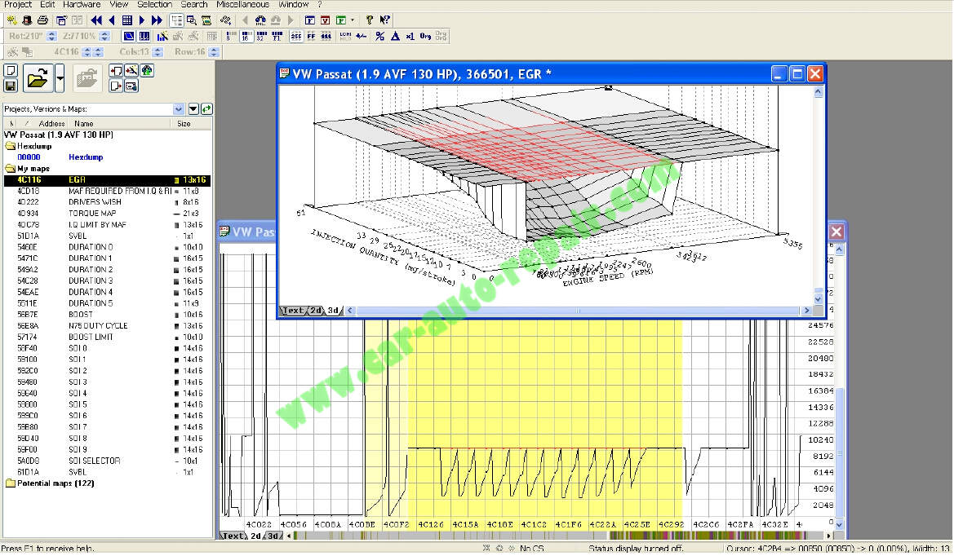

When you close the map window you will see that similar changes have happened to the “hexdump”

E.g.

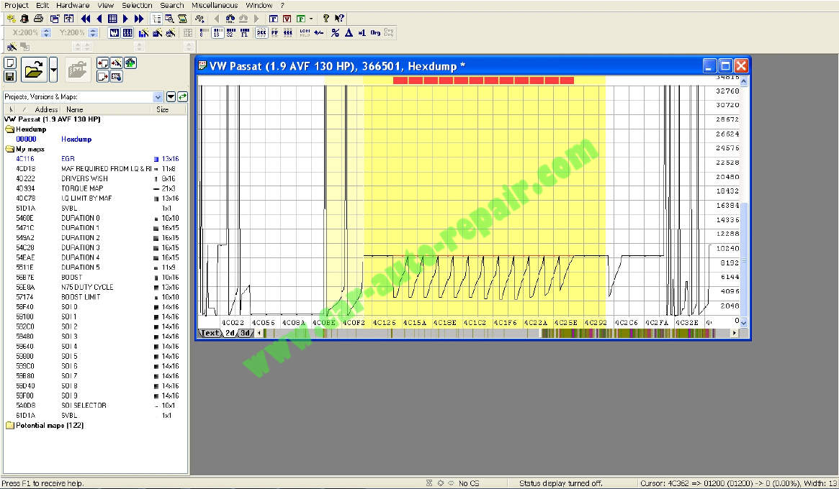

Any changes you made in the map will be automatically made in the “hexdump”. AND the changes will be made using the correct values for the hexdump.So if you had 850 set on your map as 8500 because you forgot to change the factor to 0.1, it doesn’t matter. Winols will have changed the hexdump value to the correct value of 08500.

The best way to test that you have been successful is to drive the car and log with vag-com (VCDS).Engine measuring block 003 will show you EGR specified and EGR actual. These should both read constantly at 850 or what ever value you set.